 Induction Planning Checklist

Welcome and orientation:
☐ Provide an overview of the activity using the Briefing Template including the who, what, where, how and why.
☐ Clarify my role as an LLE Representative (including whether I am speaking from my own LLE or on behalf of the LLE community)
☐ Provide details for sitting fees or honoraria (if applicable) including how and where it will be processed.
☐ Clarify the decision-making process (e.g. the activity will inform PHN decision-making or it will be shared decision-making). Refer to the engagement continuum below 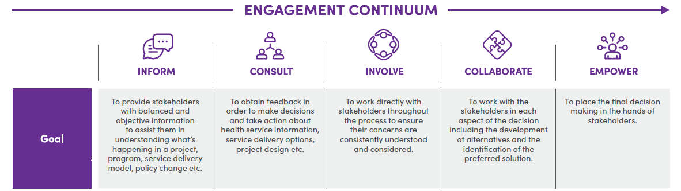
☐ Provide details of briefings or pre-readings required so I can understand the expectations for participation.
☐ Provide draft Terms of Reference (if applicable) and Shared Spaces document (if applicable)

Key contacts and support:
☐ Provide details of key contact people, their roles and contact information
☐ Provide details of how I can assess my readiness for involvement (e.g. peer or key contact person)
☐ Provide details of supports to be made available (or how this will be determined e.g. together in the first session)

Logistics and access:
☐ Confirm meeting schedule (date, time, frequency, in-person/online)
☐ Send meeting link (if online) or venue details (if in-person)
☐ Confirm accessibility needs (e.g., transport, digital access, disability support).

During meetings:
☐ Provide a peer support person to be available during meetings and discuss how this can be accessed
☐ Provide check-in and check-out activities to support self-identification of how they are feeling
☐ Discuss wellbeing and support needs, ask what works for me?
☐ Provide space and time to develop relationships and feel safe in the space

After meetings (follow-up and reflection):
☐ Provide feedback (e.g. minutes or summary of key points) and how it will be used
☐ Clarify any follow-up actions required
☐ Provide de-briefing opportunities, including a peer support person (if available)
☐ Encourage representatives to send thoughts and ideas they have after the meeting has ended (e.g. via email or key contact person)
☐ Seek feedback on the experience using the LLE Representative Evaluation Form and complete improvements/actions as required

Capability Building:
☐ Provide details of capability building options for LLE representatives (if applicable)

