 Terms of Reference Template

Title of Group:
1. Purpose
The [name of group] is established to provide insight, guidance, and recommendations based on lived and living experiences relevant to [service]. The group ensures that the voices of those directly impacted by [issue/topic] are heard and incorporated into [e.g. decision-making/policies/program development].
2. Objectives [note these should align with the overall engagement objectives of the project from the Engagement Plan]
The [name of group] aims to:
- Invite, consider or embed lived and living experience perspectives to inform and shape [e.g. policies, programs, and services].
- Ensure inclusivity, accessibility, and relevance in project activities.
- Foster meaningful engagement between decision-makers and individuals with lived and living experience.
- Advocate for equity and social justice within the scope of the project.
- Provide feedback on [e.g. communication strategies, project outcomes, processes, etc].
3. Membership
- The group will comprise [number] members with lived and living experience relevant to [issue/topic] and [number] of [others e.g. PHN staff]
- Members will be selected through [details e.g. an open, inclusive, and accessible process].
- Membership will reflect diverse backgrounds, identities, and perspectives.
- The term of membership is [e.g., one year].
- Members may step down at any time. To step down from the group, contact [insert nominated contact person].
4. Selection process and criteria
Members will be selected by [who and how]. Applications may be received through an Expression of Interest process with the following criteria:
- [insert criteria]

5. Values and Guiding Principles
Members are encouraged to be open and candid in discussing items. Members are expected to:
- Share insights based on [e.g. their personal lived and living experiences or lived experiences reflective of a group].
- Engage in regular meetings and contribute to discussions.
- Respect confidentiality, privacy and the experiences of fellow members.
- Participate in training, where necessary, to build expertise to support contributions and outcomes of the group.
- Provide constructive feedback to support continuous improvement
- Uphold the values and principles of lived experience, inclusive of working from a trauma informed perspective to ensure the safety of members. The ‘Shared Engagement Spaces’ provides general principles to inform the work of the group.
6. Meetings
- The group will meet [frequency, e.g., monthly or quarterly].
- Meetings will be conducted [online or in person or combination of both] in an accessible and supportive manner, accommodating diverse needs.
- [if applicable] Agendas will be co-developed with members to ensure relevance and participation.
- [if applicable] Decision-making will be collaborative, with consensus where possible.
7. Sitting Fees/Honorarium (if applicable)
- Members who are not otherwise attending in a paid capacity will receive an honorarium for time [add details i.e. how much, frequency and mode of payment].
8. Reporting, Decision-making and Accountability
- The [name of group] will be chaired by [position of chair]
- [include decision-making authority i.e. is it an advisory committee that can make recommendations, refer to engagement continuum below]
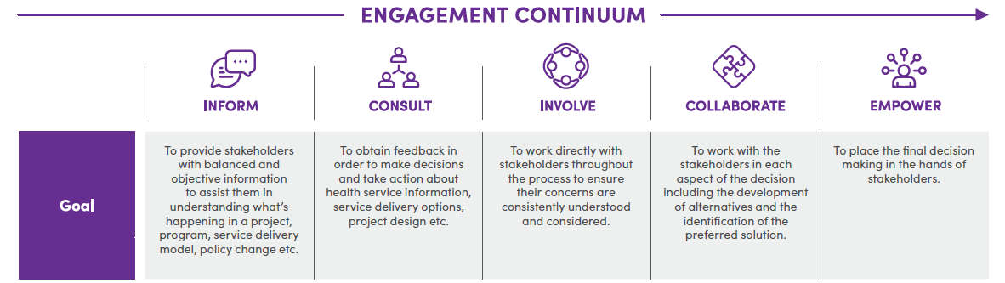

- The [name of group] will report its insights and recommendations to [decision-making body/project team if applicable].
- Feedback loops will ensure members understand how their input is used.
- A [insert frequency] review will assess the effectiveness of the group and recommend improvements.
9. Quorum
A quorum will be considered to exist when a majority of members are present [or other criteria as required]
10. Public Comment
[If applicable] Members and attendees must avoid making public comments that may appear to be an official comment from the PHN or from [name of group]. Where public statements are deemed advantageous, these shall be distributed by the PHN through approved channels.

11. Grievance processes
Members are encouraged to openly express concerns about the operation of the [name of group] within meetings. If not appropriate or suitable, members may also bring concerns to the Chair for assistance with resolution.
[Insert process to raise concerns]

12. Conflicts of Interest
Members are responsible for declaring any potential, real or perceived conflict of interest at any meeting if it relates specifically to a particular issue under consideration. Conflicts of interest will be recorded. If members are unsure if something may be a conflict of interest, they are encouraged to discuss with the Chair.
13. Review and Amendments
- These Terms of Reference will be reviewed [insert frequency e.g. annually].
- Members will be consulted on any proposed changes.

