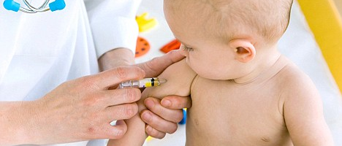

INVITATION – Online Webinar
Immunisation catch up events for practice nurses

Date: Tuesday, 23rd February 2021

Time: 12:30pm – 1:30pm

Where: Online webinar *

These events are hosted by Brisbane North PHN and presented by nurses from the Metro North Public Health Unit.
The immunisation catch up event will cover the following in a one hour session:

- What’s new in 2021
For more information please contact Aimie.thomson@brisbanenorthphn.org.au or
phone 07 3490 3429.
RSVP: Please email the following details to aimie.thomson@brisbanenorthphn.org.au by
Monday, 22nd February 2021. Only registered attendees will receive a certificate of attendance.
Name
Practice
Contact phone
Contact email
(Please provide a current email address as a confirmation email with access details to the webinar and necessary documentation will be sent to you prior to the event) *You will need to download the zoom application.

