

|  |
| --- |
| **Quality Improvement Toolkit for General Practice** |
| **My health for life** |
|  |

My health for life

**Introduction**

**The Quality Improvement Toolkit**

This Quality Improvement (QI) Toolkit is made up of modules that are **designed to support your practice to make easy, measurable and sustainable improvements to provide best practice care for your patients.** The Toolkit will help your practice complete Quality Improvement (QI) activities using the Model for Improvement.

Throughout the modules you will be guided to explore your data to understand more about your patient population and the pathways of care being provided in your practice. Reflections from the module activities and the related data will inform improvement ideas for you to action using the Model for Improvement.

The Model for Improvement uses the Plan-Do-Study-Act (PDSA) cycle, a tried and tested approach to achieving successful change. It offers the following benefits:

* it is a simple approach that anyone can apply
* it reduces risk by starting small
* it can be used to help plan, develop and implement change that is highly effective.

The Model for Improvement helps you break down your change into manageable pieces, which are then tested to ensure that the change results in measurable improvements.

There is a high cholesterol referral example using the Model for Improvement and a blank template for you to complete at the end of this module.

If you would like additional support in relation to quality improvement in your practice, please contact your Brisbane North PHN Primary Care Liaison Officer (07 3630 7300).

This icon indicates that the information relates to the ten Practice Incentive Program (PIP) Quality Improvement (QI) measures.

Due to constant developments in research and health guidelines, the information in this document will need to be updated regularly. Please [contact](mailto:optimalcare@bsphn.org.au) Brisbane North PHN if you have any feedback regarding the content of this document.

**Acknowledgements**

We would like to acknowledge that some material contained in this Toolkit has been extracted from organisations including the Institute for Healthcare Improvement, the Royal Australian College of General Practitioners (RACGP); the Australian Government Department of Health; Best Practice; Medical Director, CAT4 and Train IT. These organisations retain copyright over their original work and we have abided by licence terms. Referencing of material is provided throughout.

While the Australian Government Department of Health has contributed to the funding of this material, the information contained in it does not necessarily reflect the views of the Australian Government and is not advice that is provided, or information that is endorsed, by the Australian Government. The Australian Government is not responsible in negligence or otherwise for any injury, loss or damage however arising from the use of or reliance on the information provided herein.

The information in this Toolkit does not constitute medical advice and Brisbane North PHN accept no responsibility if information in this toolkit is interpreted or used.

Unless otherwise indicated, material in this booklet is owned by Brisbane North PHN. You are free to copy and communicate the work in its current form, as long as you attribute Brisbane North PHN as the source of the copyright material.



Table of Contents

My Health for Life overview 7

The goals of the *My Health for Life* program 7

How *My Health for Life* will help your patients 8

What are the criteria to participate in the *My health for life* program? 8

Who is ineligible to participate in the *My health for life* program? 9

Is GP consent required to participate in the *My health for life* program? 9

What are the key program outcomes to date? 10

Activity 1. Understanding your patient population 11

Activity 1.1 – Data collection from CAT4 11

Activity 1.2– Reviewing your patient’s eligible for the *My health for life* program 12

Activity 1.3 – Data collection from CAT4 13

Activity 1.4– Reviewing your patient’s with incomplete CV event risk data recorded 14

Activity 2. *My health for life* and RACGP accreditation standards 16

RACGP 5th Edition Accreditation Standards & Preventive Health 16

Activity 2.1– Reviewing your practice’s preventive health activities 16

Activity 3. *My health for life* and prevention activities and assessments 20

Activity 3.1 – Data collection from CAT4 20

Activity 3.2– Reviewing your patient’s preventive health measures 21

Activity 3.3 – Recording preventive health results in your clinical software 23

*My health for life* health score test 24

Cardiovascular Risk Calculator 24

Best Practice Cardiovascular Risk Calculator 24

Medical Director Cardiovascular Risk Calculator 25

Managing people at risk of developing Type II diabetes 26

AUSDRISK tool – what is included? 27

Instructions on completing AUSDRISK tool in Best Practice 27

Instructions on entering measurements into Best Practice 28

Instructions for entering smoking status in Best Practice 29

Instructions on entering measurements into Medical Director 30

Instructions on entering smoking status into Medical Director 30

Recording physical activity in your clinical software (Medical Director) 31

Entering physical activity information in the patient file in Medical Director 31

Recording risk factors in your clinical software (Best Practice) 32

Entering physical activity information in the patient file in Best Practice 32

Activity 4. *My health for life* and Medicare item numbers 33

Health assessments (MBS items 701-707) 33

Health assessments and Medicare 33

Completing Health Assessment templates on Medical Director 33

Completing Health Assessment templates on Best Practice 34

Healthy Heart Check (MBS item 699) 34

Who is eligible for a Healthy Heart Check? 35

Healthy Heart Assessment & Medicare 35

Importing Healthy Heart Check template into Best Practice 35

Completing Health Heart Check template in Medical Director 35

Aboriginal and Torres Strait Islander Health Assessment (MBS item 715) 35

Who is eligible for an Aboriginal and Torres Strait Islander Health Assessment 36

Aboriginal and Torres Strait Islander Assessment and Medicare 36

Completing Aboriginal and Torres Strait Islander Health Assessments on Medical Director 36

Completing Aboriginal and Torres Strait Islander Health Assessments on Best Practice 37

Activity 4.1 – Data collection from billing software package 38

Instructions - Identifying the number of chronic disease item numbers claimed in Pracsoft. 39

Instructions - Identifying the number of chronic disease item numbers claimed in Best Practice 40

Activity 4.2– Review MBS item number claiming at your practice 41

Tools to help utilise MBS item numbers 42

Medicare item numbers and Topbar 42

Provider digital access (PRODA) 43

For more information about Topbar or PRODA: 43

Activity 5. *My health for life* referral process & patient journey 44

*My health for life* referral form templates 45

Referral Templates 45

*My health for life* group facilitators 45

Activity 5.1– Review referral process for the *My health for life* program 46

Activity 6. Recall and reminders 48

Reminders, recalls and prompts (flags) 48

Train IT Medical – Recall and reminder resources for Medical Director 48

Train IT Medical – Recall and reminder resources for Best Practice 48

Activity 6.1 – Reminder system 49

Recommendation – other methods for engaging patients 50

Activity 7. *My health for life* resources and training 51

Guidelines 51

Tools 51

Resources 51

Training and information 51

How to adopt an absolute risk approach in your practice (5 short interviews with leading experts) 52

Information for patients: 52

How your general practice can get involved 53

Quality Improvement Activities using The Model for Improvement and PDSA 54

Model for Improvement and PDSA worksheet EXAMPLE 56

Model for Improvement and PDSA worksheet template 59

## My Health for Life overview

My health for life (MH4L) is a free behaviour change program designed for people at high risk of developing a chronic disease. The program shows participants that making small lifestyle changes can have major health benefits.

The program works in partnership with general practice and is a practical extension of the advice given by GPs and nurses to their patients.

## The goals of the *My Health for Life* program

The goals of the *My health for life* program are:

* to effectively identify people at high risk of developing chronic disease, and provide them with an appropriate behaviour modification program
* to increase health literacy levels and the capacity of program participants to adopt and maintain positive health behaviours to manage their health risk factors
* to improve community awareness, knowledge and attitudes about chronic disease risk factors and how to make positive health behaviour choices

For more information visit [www.myhealthforlife.com.au](http://www.myhealthforlife.com.au/)

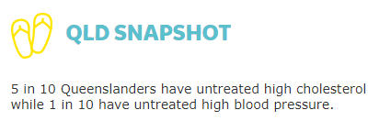

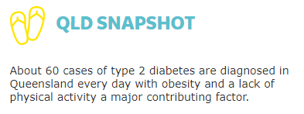

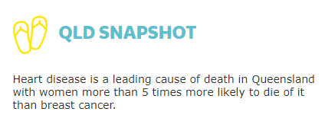

## How *My Health for Life* will help your patients

The *My health for life* program works in partnership with GPs

Providing patients an opportunity to participate in an evidence-based health behaviour modification program in their local community.

Access to facilitators; who are trained health professionals, including dietitians and exercise physiologists and have a keen interest in preventative health.

*My health for life* is a practical extension of the advice given by GPs to their patients; allowing participants to better understand their health risks and supporting them to achieve their health-related goals.

GPs will be kept informed of their patient’s progress, completing the care cycle.

Health professionals are a critical part of the *My health for life program*

## What are the criteria to participate in the *My health for life* program?

## Who is ineligible to participate in the *My health for life* program?

## Is GP consent required to participate in the *My health for life* program?

## What are the key program outcomes to date?

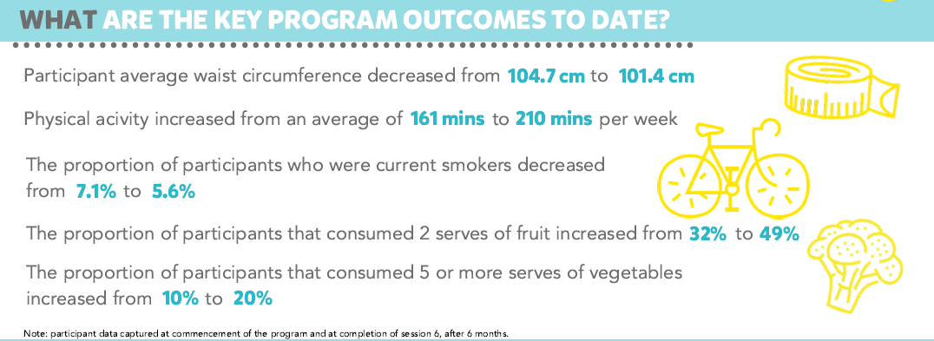

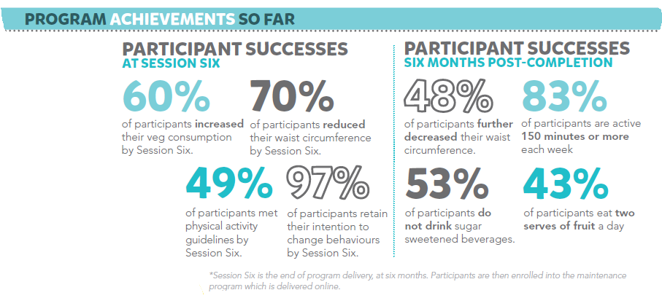[1]

Toolkit Aim - To identify who in your practice is eligible for the My health for life program and refer them for health intervention programs

To achieve this, you will need to extract patient data and establish a valid patient list or register.

The following activities will help guide you through the process. There are additional activities to find any patients who may have been missed in the initial data extraction activity and to ensure they are then coded correctly. These activities will improve the accuracy of the register and maintain the system for the future.

Once you have an accurate register you will be able to easily identify how your patients are being managed and what needs to happen within the practice to optimise patient care.

Please note: completing the data tables alone in the workbooks does not constitute a quality improvement activity rather they are designed to inform areas for quality improvement and that a model for improvement should be completed to meet PIP QI requirements

## Activity 1. Understanding your patient population

### Activity 1.1 – Data collection from CAT4

The aim of this activity is to collect data to identify patients who may be eligible for the My health for life program

Complete the below table by collecting data from your CAT4 Data Extraction Tool.

Note - Instructions on how to extract the data is available from the CAT4 website under [*My health for life*](https://help.pencs.com.au/display/CR/My+Health+For+Life+Recipes) **OR** [patients at risk of developing type 2 diabetes](https://help.pencs.com.au/display/CR/Identify+Patients+at+Risk+of+Diabetes+Mellitus+Type+II).

|  | Description | Total number of active patients as per RACGP criteria (3 x visits in 2 years) | Total number of active patients |
| --- | --- | --- | --- |
| 1.1a | Identify patient population (Active 3x visits in 2 years)  See instructions in link below.  [Identify active patients with at least 3 visits in the last 2 years](https://help.pencs.com.au/display/CR/Identify+active+patients+with+at+least+3+visits+in+the+last+2+years) |  |  |
| 1.1b | Number of patients at high risk eligible for the *My health for life* program |  |  |
| 1.1c | Number of indigenous patients eligible for the *My health for life* program |  |  |
| 1.1d | Number of patients with high CV risk eligible for the *My health for life* program |  |  |
| 1.1e | Number of patients with familial hypercholesterolaemia eligible for the *My health for life* program |  |  |
| 1.1f | Number of patients with high blood pressure eligible for the *My health for life* program |  |  |
| 1.1g | Number of patients with high cholesterol eligible for the *My health for life* program |  |  |
| 1.1h | Number of patients with previously diagnosed gestational diabetes |  |  |
| 1.1i | Number of patients with impaired fasting glucose or impaired glucose tolerance |  |  |

Please note: the RACGP defines active as 3 x visits in 2 years. This search criteria does not capture those patients who may come in for screening every 2 years, or twice in 2 years e.g. flu vaccine, hence the option to look at all active patients.

Reflection comments as a result of completing Activity 1.1:

|  |
| --- |
|  |
|  |
|  |
|  |
| **Practice name: Date:** |
| **Team member:** |

### Activity 1.2– Reviewing your patient’s eligible for the *My health for life* program



*Complete the checklist below which reviews your practices patients eligible for the My health for life program.*

| **Description** | **Status** | **Action to be taken** |
| --- | --- | --- |
| After completing activity 1.1 are there any unexpected results with your practice’s *My health for life* eligible patients? |  Yes: **see actions to be taken**   No: continue with activity | Please explain: (*for e.g. high number of patients with high CV risk or only a low number of patients with high cholesterol eligible for the program)*  How will this information be communicated to the practice team? |
| Have you created a TopBar prompt on all patients who may be eligible for the *My health for life* program? |  Yes: continue with activity   No: **see actions to be taken** | Follow the [instructions](http://help.pencs.com.au/display/CG/Creating+a+Prompt+in+CAT4) to complete this |
| After reviewing your practices *My health for life* profile, are there any changes you would like to implement in the practice to help manage patients over the next 12 months? |  Yes: **see actions to be taken**   No: you have completed this activity | Refer to the Model for Improvement (MFI) and the Thinking part at the end of this document  Refer to the Doing part - PDSA of the Model for Improvement (MFI) to test and measure your ideas for success |

Reflection comments as a result of completing Activity 1.2:

|  |
| --- |
|  |
|  |
|  |
|  |
| **Practice name: Date:** |
| **Team member:** |

### Activity 1.3 – Data collection from CAT4

The aim of this activity is to collect data to identify patients who are missing cardiovascular event risk data to ensure data is correctly entered.

Complete the below table by collecting data from your CAT4 Data Extraction Tool.

Note - Instructions on how to extract the data is available from the CAT4 [website](https://help.pencs.com.au/display/CR/Find+patients+eligible+for+My+Health+For+Life+with+high+CV+Event+risk).

Please note: CV event risk factors include smoking, cholesterol, HDL, BP, age and gender

|  | Description | Total number of active patients as per RACGP criteria (3 x visits in 2 years) | Total number of active patients |
| --- | --- | --- | --- |
| 1.3a | Number of patients with incomplete CV event risk data recorded |  |  |
| 1.3b | Number of patients with 3 or more CV event measures incomplete |  |  |

Please note: after you have completed this activity and any missing data is entered, you may find other patients eligible for the *My health for life* program

Reflection comments as a result of completing Activity 1.3:

|  |
| --- |
|  |
|  |
|  |
|  |
| **Practice name: Date:** |
| **Team member:** |

### Activity 1.4– Reviewing your patient’s with incomplete CV event risk data recorded



*Complete the checklist below which reviews your practices patients with incomplete CV event risk data*

| **Description** | **Status** | **Action to be taken** |
| --- | --- | --- |
| After completing activity 1.3 are there any unexpected results with your practice’s incomplete CV event risk data? |  Yes: **see actions to be taken**   No: continue with activity | Please explain: (*for e.g. high number of patients with 3 or more risk factors missing)*  How will this information be communicated to the practice team? |
| Have you created a TopBar prompt on all patients who have incomplete CV event risk data? |  Yes: continue with activity   No: **see actions to be taken** | Follow the [instructions](http://help.pencs.com.au/display/CG/Creating+a+Prompt+in+CAT4) to complete this |
| Do you know how to generate the report for individual providers? |  Yes: continue with activity   No: **see actions to be taken** | Follow the [instructions](https://help.pencs.com.au/display/CR/Identify+patients+seen+by+a+particular+provider+or+group+of+providers) to complete this on CAT4 |
| After reviewing your practices incomplete CV event risk data, are there any changes you would like to implement in the practice to help manage patients over the next 12 months? |  Yes: **see actions to be taken**   No: you have completed this activity | Refer to the Model for Improvement (MFI) and the Thinking part at the end of this document  Refer to the Doing part - PDSA of the Model for Improvement (MFI) to test and measure your ideas for success |

Reflection comments as a result of completing Activity 1.4:

|  |
| --- |
|  |
|  |
|  |
|  |
| **Practice name: Date:** |
| **Team member:** |

## Activity 2. *My health for life* and RACGP accreditation standards

## RACGP 5th Edition Accreditation Standards & Preventive Health

**Criterion C4.1 – Health Promotion and Preventive Care**

C4.1A Our patients receive appropriately tailored information about health promotion, illness prevention, and preventive care.

According to the [RACGP 5th edition accreditation standards](https://www.racgp.org.au/running-a-practice/practice-standards/standards-5th-edition/standards-for-general-practices-5th-ed), assessing a patient’s health risks is an important component of preventive care, part of which is early detection of disease. it is a requirement of the standards that practices must document in the patient’s health records discussions or activities relating to preventive health.

Strategies that practices may implement include:

* use preventive health guidelines and resources
* hand out up-to-date pamphlets and brochures
* provide information on the practice’s website
* run preventive health activities, such as diabetic education groups and groups to help patients quit smoking
* have a reminder system to prompt patients of screening activities

### Activity 2.1– Reviewing your practice’s preventive health activities



*Complete the checklist below which reviews your practices preventive health activities.*

| **Description** | **Status** | **Action to be taken** |
| --- | --- | --- |
| Does your practice have preventive health guidelines available to relevant team members? |  Yes: see actions to be taken   No: see actions to be taken | Are the guidelines up to date?   Yes  No  How often are the guidelines checked for currency?   Weekly   Monthly   Quarterly   Annually   Other: ___________________  Who has the responsibility to check for up to date guidelines?  ____________________________  ____________________________ |
| Refer to the [RACGP Guidelines for Prevention in General Practice](https://www.racgp.org.au/FSDEDEV/media/documents/Clinical%20Resources/Guidelines/Red%20Book/Guidelines-for-preventive-activities-in-general-practice.pdf) |
| Does your practice have pamphlets and brochures available for patients? |  Yes: **see actions to be taken**   No: **see actions to be taken** | Are the pamphlets/brochures up to date?   Yes  No  How often are the pamphlets/brochures checked for currency?   Weekly   Monthly   Quarterly   Annually   Other: ___________________  Who has the responsibility to check the pamphlets/brochures?  ____________________________ |
| Talk to your Primary Care Liaison Officer to discuss the best way to access patient pamphlets and brochures |
| Does your practice have health promotion information on the practice’s website? |  Yes: **see actions to be taken**   No: **see actions to be taken** | Is this information up to date?   Yes  No  How often is the website checked for currency?   Weekly   Monthly   Quarterly   Annually   Other: ___________________  Who has the responsibility to update the contents of website?  ____________________________ |
| Discuss with relevant team members what information could be included on the practice website |
| Do health professionals document in the patient’s file when preventive health information is provided? |  Yes: continue with activity   No: **see actions to be taken** | Print patient information brochures from Medical Director or Best Practice. This information is automatically documented in the patient file  Discuss at your next team meeting how to ensure relevant team members are documenting information |
| After reviewing your practices preventative health information sharing strategies, are there any changes you would like to implement in the practice to help manage patients over the next 12 months? |  Yes: **see actions to be taken**   No: you have completed this activity | Refer to the Model for Improvement (MFI) and the Thinking part at the end of this document  Refer to the Doing part - PDSA of the Model for Improvement (MFI) to test and measure your ideas for success |

Reflection comments as a result of completing Activity 2.1:

|  |
| --- |
|  |
|  |
|  |
|  |
| **Practice name: Date:** |
| **Team member:** |

## Activity 3. *My health for life* and prevention activities and assessments

General practice is at the forefront of healthcare in Australia and in a pivotal position to deliver preventive healthcare. More than 137 million general practice consultations take place annually in Australia and 85% of the Australian population consult a general practitioner (GP) at least once a year. Preventive healthcare is an important activity in general practice. It includes the prevention of illness, the early detection of specific disease, and the promotion and maintenance of health. The partnership between GP and patient can help people reach their goals of maintaining or improving health. Preventive care is also critical in addressing the health disparities faced by disadvantaged and vulnerable population groups.

Prevention of illness is the key to Australia’s future health – both individually and collectively. About 32% of Australia’s total burden of disease can be attributed to modifiable risk factors. [2]

The aim of this activity is to identify prevention activities that can be completed in general practice.

## Activity 3.1 – Data collection from CAT4

The aim of this activity is to collect data to review preventive health measures in your practice.

Complete the below table by collecting data from your CAT4 Data Extraction Tool.

Note - Instructions on how to extract the data is available from the CAT4 website [Smoking status](https://help.pencs.com.au/pages/viewpage.action?pageId=47317090) OR [BMI](https://help.pencs.com.au/pages/viewpage.action?pageId=47317101) OR [elevated CV risk](https://help.pencs.com.au/display/CR/Identify+elevated+CV+risk+-+Part+A) OR [identify patients at risk of developing type 2 diabetes](https://help.pencs.com.au/display/CR/Identify+Patients+at+Risk+of+Diabetes+Mellitus+Type+II) OR [patients with previous fracture](https://help.pencs.com.au/display/CG/Amgen+REFRAME+Program) OR [physical activity script](https://help.pencs.com.au/display/CG/Physical+Activity)

|  | Description | Total number of active patients as per RACGP criteria (3 x visits in 2 years) | Total number of active patients |
| --- | --- | --- | --- |
| 3.1a | Number of patients aged ≥ 45 years who are smokers |  |  |
| 3.1b | Number of indigenous patients aged ≥ 18 years who are smokers |  |  |
| 3.1c | Number of patients aged ≥ 45 years who have a BMI classification of overweight, obese and morbid |  |  |
| 3.1d | Number of indigenous patients aged ≥ 18 years who have a BMI classification of overweight, obese and morbid |  |  |
| 3.1e | Number of patients aged ≥ 45 years with elevated CV risk |  |  |
| 3.1f | Number of indigenous patients aged ≥ 18 years with elevated CV risk |  |  |
| 3.1g | Number of patients aged ≥ 45 years who are at risk of developing type 2 diabetes |  |  |
| 3.1h | Number of indigenous patients aged ≥ 18 years who are at risk of developing type 2 diabetes |  |  |
| 3.1i | Number of patients aged ≥ 50 years who have had a previous fracture |  |  |
| 3.1j | Number of patients with their physical activity status recorded |  |  |

Please note: the RACGP defines active as 3 x visits in 2 years. This search criteria does not capture those patients who may come in for screening every 2 years, or twice in 2 years e.g. flu vaccine, hence the option to look at all active patients.

Reflection comments as a result of completing Activity 3.1:

|  |
| --- |
|  |
|  |
|  |
|  |
| **Practice name: Date:** |
| **Team member:** |

## Activity 3.2– Reviewing your patient’s preventive health measures



*Complete the checklist to outline the prevention health measures in your practice*

| **Description** | **Status** | **Action to be taken** |
| --- | --- | --- |
| After completing activity 3.1 are there any unexpected results with your practice’s preventive health measures? |  Yes: **see actions to be taken**   No: continue with activity | Please explain: (*for e.g. high number of patients with high CV risk or only a low number of patients with smoking status recorded)*  How will this information be communicated to the practice team? |
| Do relevant team members know where to access the *My health for life* health score test? |  Yes: continue with activity   No: **see actions to be taken** | Refer to the MH4L [website](https://www.myhealthforlife.com.au/risk-assessment) |
| Do relevant team members know where to access the type 2 diabetes risk assessment tool? |  Yes: continue with activity   No: **see actions to be taken** | The assessment tool can be obtained [here](https://www1.health.gov.au/internet/main/publishing.nsf/Content/chronic-diab-prev-aus) |
| After reviewing your practices preventative health measures, are there any changes you would like to implement in the practice to help manage patients over the next 12 months? |  Yes: **see actions to be taken**   No: you have completed this activity | Refer to the Model for Improvement (MFI) and the Thinking part at the end of this document  Refer to the Doing part - PDSA of the Model for Improvement (MFI) to test and measure your ideas for success |

Reflection comments as a result of completing Activity 3.2:

|  |
| --- |
|  |
|  |
|  |
|  |
| **Practice name: Date:** |
| **Team member:** |

## Activity 3.3 – Recording preventive health results in your clinical software

*The aim of this activity is to review if relevant team members know where to record preventive health results in your clinical software program.*

| Description | Status | Action to be Taken |
| --- | --- | --- |
| Are all the preventive health results being recorded in the correct fields in your clinical software? (for e.g. Height, weight, BMI, smoking status, alcohol status, physical activity) |  Yes: continue with activity   No, **see action to be taken** | Review how and where your preventive health information is being recorded in your practice software.  Refer to CAT4 recipes for [Improving Data Quality](https://help.pencs.com.au/display/CR/Improve+Data+Quality)  Ensure all relevant team members are aware of how to record cardiovascular disease risk factor information  Document in practice policy |
| Do relevant staff know where to enter preventive health results in your clinical software package? |  Yes: continue with activity   No: **see action to be taken** | Best Practice users refer here  Medical Director users refer here  Contact your local Primary Care Liaison Officer on 3490 3490 (North Lakes) or 3630 7300 (Lutwyche) |
| Do relevant team members understand the importance of using drop down lists provided with your clinical software program? |  Yes: you have completed this activity   No: **see action to be taken** | Provide training to all team members on importance of data entry |

Reflection comments as a result of completing Activity 3.5:

|  |
| --- |
|  |
|  |
|  |
|  |
| **Practice name: Date:** |
| **Team member:** |

## *My health for life* health score test

People are often unaware of their risk of developing future health conditions because they currently feel okay or there are no obvious signs to indicate that their risk of chronic conditions is high. *My health for life* have an online health check that people can use to determine their personal risk. This tool is available [here](https://www.myhealthforlife.com.au/risk-assessment)

## Cardiovascular Risk Calculator

The Australian Absolute cardiovascular disease risk calculator has been produced by the National Vascular Disease Prevention Alliance for the information of health professionals. To use the calculator, you will need patients age, blood pressure, smoking status, total and hdl cholesterol and ECG LVH if know. This calculator can be accessed at <http://www.cvdcheck.org.au/> . It is also included in Best Practice and Medical Director.

### Best Practice Cardiovascular Risk Calculator

1. Open patient file.

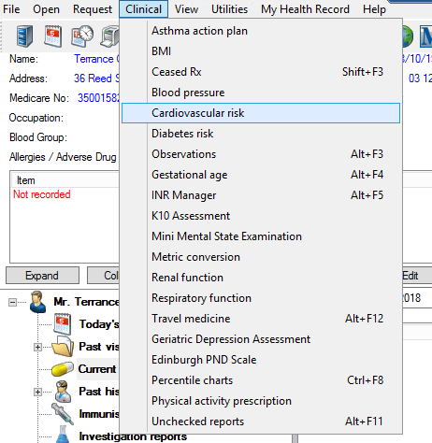

1. Select **Clincial** and **Cardiovascular Risk**
2. The Cardiovascular risk screen will open

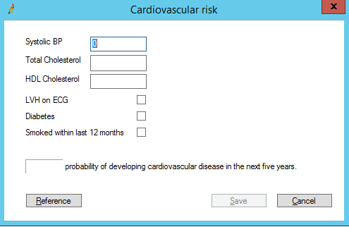

1. Enter patient results in the appropriate box. After all the details have been entered a score will appear.
2. Click save for this to be recorded in patients file

### Medical Director Cardiovascular Risk Calculator

1. Open patient file.
2. Select **Tools**, **Tool Box** & **Cardiovascular Risk**

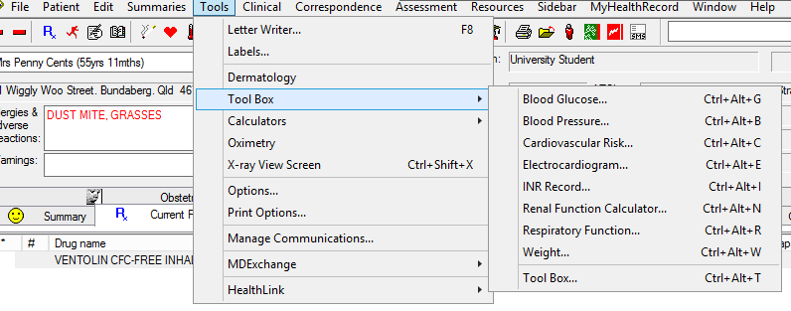

1. The Cardiovascular Risk Calculator screen will appear

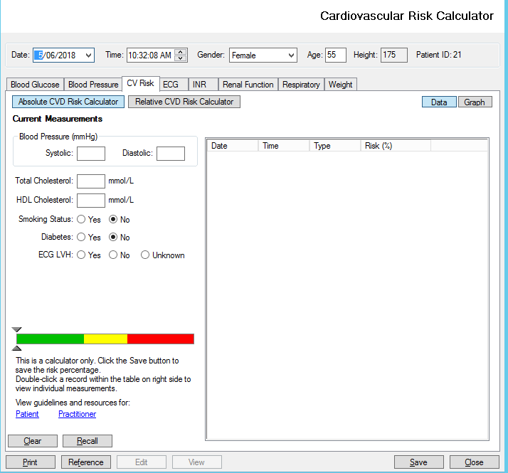

1. Enter the patient results in the appropriate boxes. The result will appear on the calculator guide
2. Click **save** and this results will be saved in the patient’s file

## Managing people at risk of developing Type II diabetes

Life style modifications such as physical activity, dietary change and weight loss should be trialled before considering the use of pharmacological interventions for the prevention of type 2 diabetes in high risk individuals.

The Australian Risk Assessment Tool (AUSDRISK) should be used to identify people at high risk of developing diabetes.

* A risk score of 12 should be used to categorise high risk.
* Risk assessment should begin at age 40 and from age 18 in Aboriginal and Torres Strait Islanders*.
* Risk assessment should be repeated every 3 years.

* It should be noted that the AUSDRISK may overestimate risk in those under 25 years of age and underestimate risk in Aboriginal and Torres Strait Islanders.

In absence of specific strategies targeting low socio-economic people, strategies aimed at the general population are recommended. Culturally appropriate lifestyle interventions should be provided in accessible settings. [3]

### AUSDRISK tool – what is included?

The Australian Risk Assessment Tool (AUSDRISK) asks for the following information:

* Age
* Gender
* Ethnicity/country of birth
* Family history of diabetes
* Previous history of high blood sugar including gestation diabetes
* Currently on blood pressure medication
* Smoking status
* Physical activity levels
* Waist measurement

The assessment tool can be obtained [here](https://www1.health.gov.au/internet/main/publishing.nsf/Content/chronic-diab-prev-aus).

### Instructions on completing AUSDRISK tool in Best Practice

1. Open the patient’s file
2. From the top menu, select **Clinical** and **Diabetes risk**

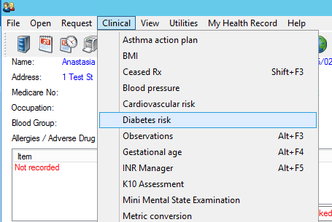

1. The assessment will open. Complete as appropriate 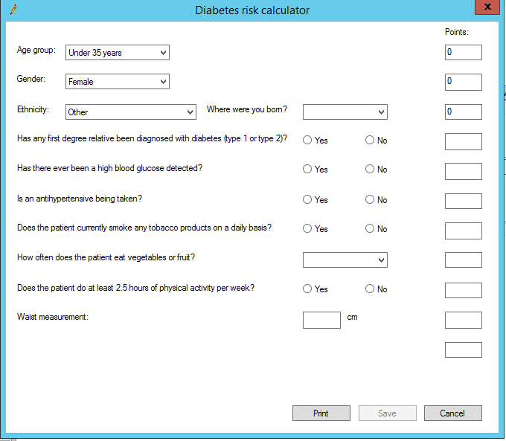
2. Click **Save** to complete

### Instructions on entering measurements into Best Practice

1. Have the patient’s file open
2. From the top menu, select **Clinical** and then **Observations**

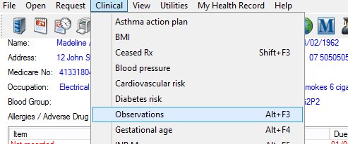

1. Enter the appropriate information

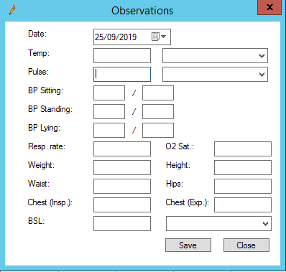

1. Click **save** to complete

### Instructions for entering smoking status in Best Practice

1. While the patient file is open, select **Open** and **alcohol & smoking history**

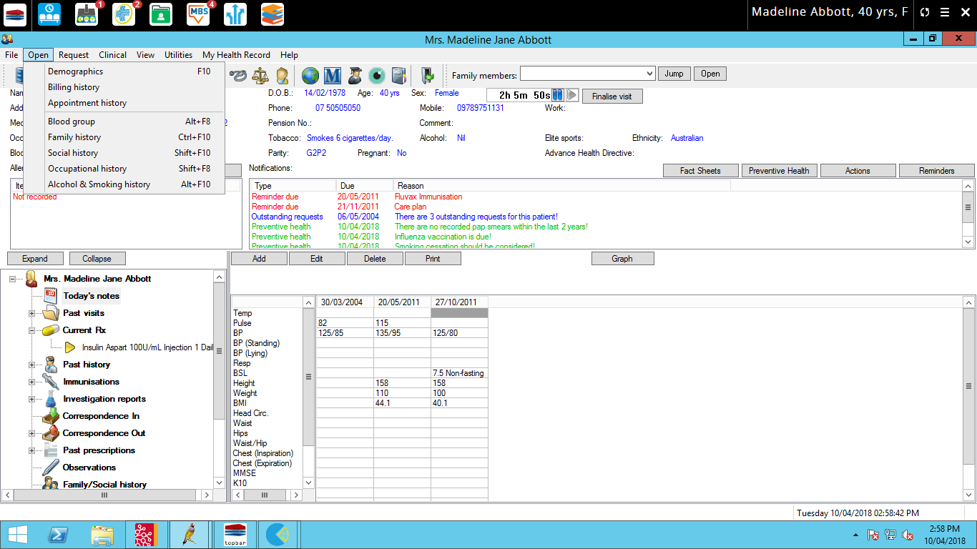

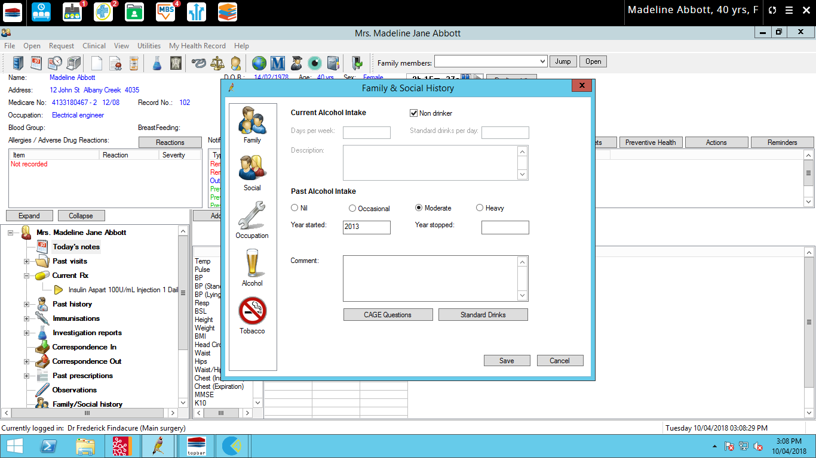

1. Select Tobacco on the left-hand side menu
2. Once you have entered the information, select **Save**

### Instructions on entering measurements into Medical Director

1. Have the patient’s file open
2. From the top menu select **Tools**, **Tool Box** & **Tool Box**

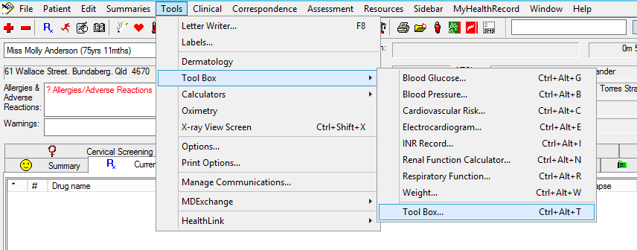

1. Select the appropriate tab and enter the relevant information

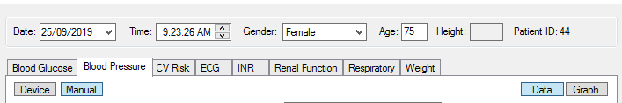

1. Click **save** to complete.

### Instructions on entering smoking status into Medical Director

1. 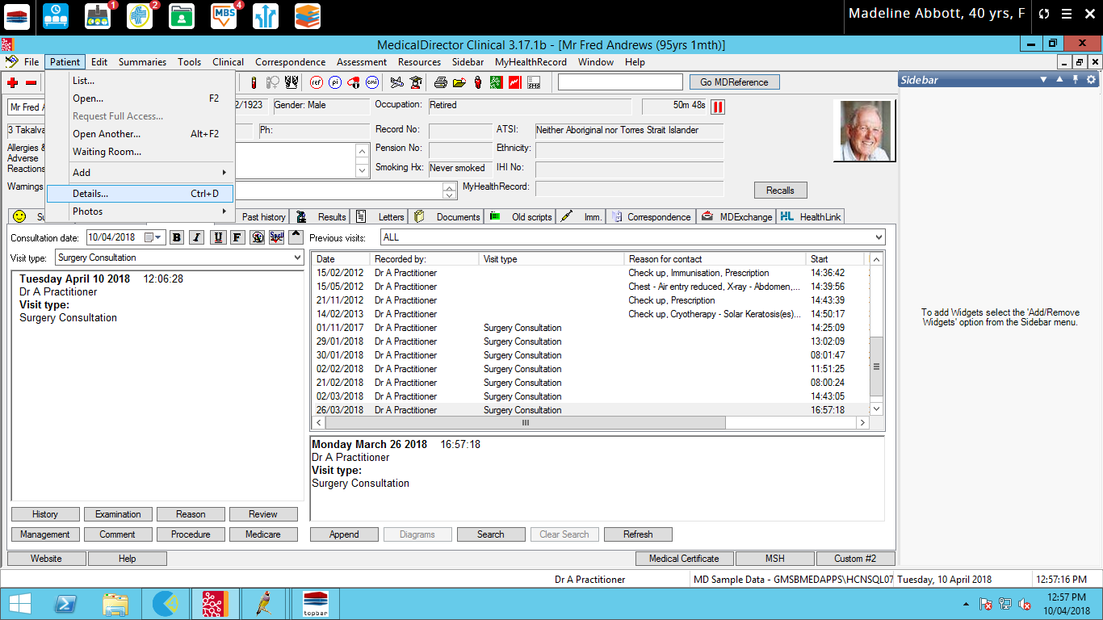Have the patient file open
2. From the ‘**patient’** menu select ‘**details**’
3. This will then open up a screen where you can enter patient details, allergy/reactions, family/social history, smoking, alcohol and personal details.
4. Select **Smoking**
5. 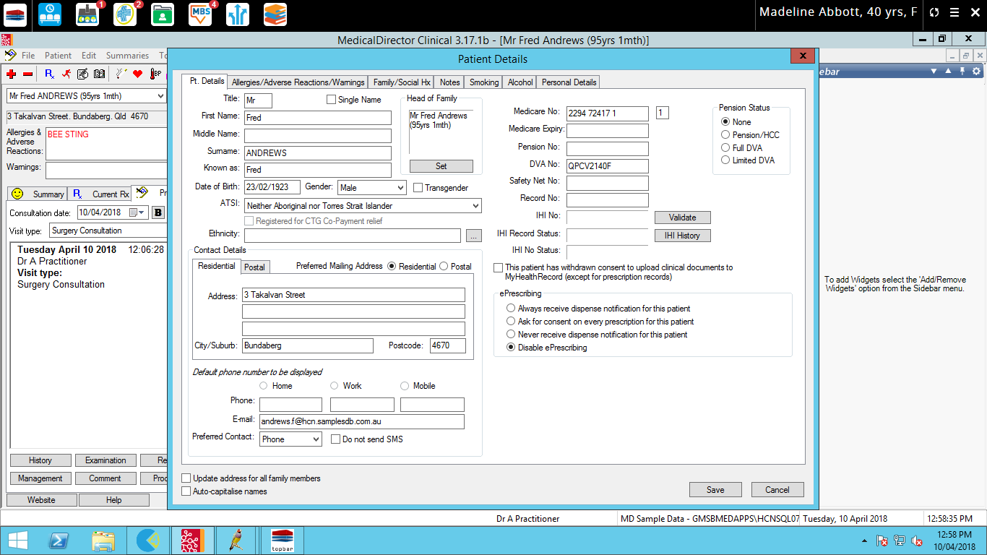Once you have entered the details, select **save.**

### Recording physical activity in your clinical software (Medical Director)

It is important to record activities in the correct data fields and avoid entering the activities as ‘free text’ in the progress notes. By recording the information in the correct fields, it will:

* improve efficiency when using Medical Director by reducing the amount of time searching for information in the patient progress notes
* improve consistency in how data is entered across all patients at the practice
* allow the Pen CAT4 Audit tool to extract accurate data on patients.

### Entering physical activity information in the patient file in Medical Director

1. Have the patient file opened
2. Click on the **Physical Activity** Prescription (red person running) on the toolbar

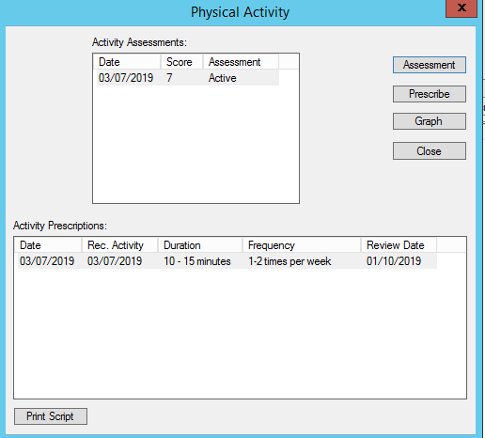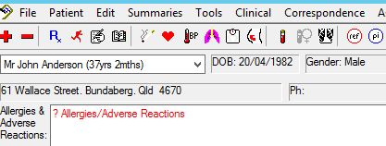

1. You can then complete an assessment or prescribe the patient a physical activity prescription.

### Recording risk factors in your clinical software (Best Practice)

It is important to record activities in the correct data fields and avoid entering the activities as ‘free text’ in the progress notes. By recording the information in the correct fields, it will:

* improve efficiency when using Best Practice by reducing the amount of time searching for information in the patient progress notes
* improve consistency in how data is entered across all patients at the practice
* allow the Pen Clinical Audit tool to extract accurate data on patients with cardiovascular disease and/or chronic kidney disease.

## Entering physical activity information in the patient file in Best Practice

1. Have the patient file opened
2. Select **‘Clinical’** and **‘Physical Activity Prescription’**

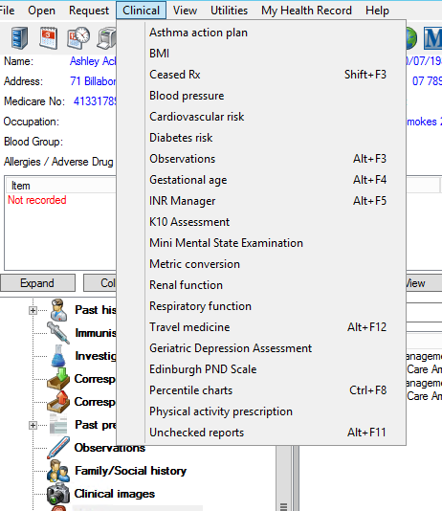

1. Complete the physical activity by using the drop-down menu options
2. Click ‘**Print**’ to save.

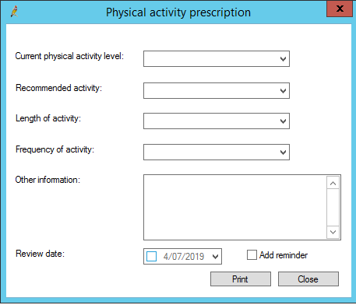

## Activity 4. *My health for life* and Medicare item numbers

*The aim of this activity is to outline some of the Medicare item numbers that you may use in general practice for eligible patients. By completing one of these item numbers, you may identify a patient who may benefit from a referral to the My Health for Life program. Instructions are also included on how to complete the templates in Best Practice and Medical Director.*

## Health assessments (MBS items 701-707)

There are time-based MBS health assessment items: 701 (brief), 703 (standard), 705 (long) and 707 (prolonged). If you are a non-vocationally registered GP, the following item numbers can be claimed: 224 (brief), 225 (standard), 226 (long) and 227 (prolonged). The following categories of health assessments may be undertaken by a medical practitioner under these items:

* people aged 40 to 49 years (inclusive) with a high risk of developing type 2 diabetes as determined by the Australian type 2 diabetes risk assessment [tool](https://www1.health.gov.au/internet/main/publishing.nsf/Content/chronic-diab-prev-aus)
* people between the age of 45 and 49 (inclusive) who are at risk of developing a chronic disease

More information available here.

### Health assessments and Medicare

Updates on the Medicare Benefit Schedule (MBS) item numbers including fees and item number criteria is available at www.mbsonline.gov.au. After you have searched the item number please make sure that you read all the explanation codes by clicking on the *See para*. Full details about the MBS Health Assessment item numbers can be found here.

### Completing Health Assessment templates on Medical Director

1. Open patient’s file
2. Select **Assessment**
3. On the assessment menu, select **Health Assessment**

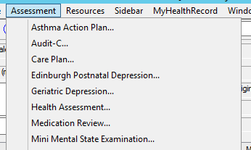

1. Complete the health assessment by following the prompts on the screen.

### Completing Health Assessment templates on Best Practice

1. Open the patient’s file

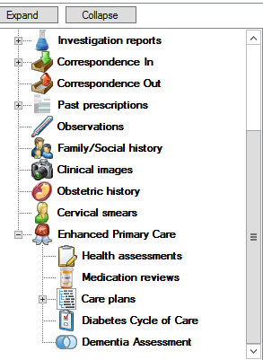

1. Click on the **plus** next to **Enhanced Primary Care**
2. 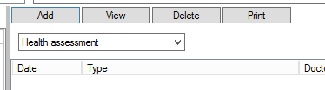Select **Health Assessment**
3. Click on **Add**
4. Complete the fields for the **Health Assessment**.

## Healthy Heart Check (MBS item 699)

Cardiovascular disease (CVD) is a leading cause of death in Australia, with more than 43,000 deaths attributed to the disease in 2017. In Australia someone dies every 12 minutes from cardiovascular disease. Modifiable CVD risk factors are responsible for 90% of the risk of myocardial infarction providing evidence CVD is largely preventable. People at high risk of CVD are often not receiving guideline recommended blood pressure and lipid lowering therapy. The federal government has a MBS item number, **699 (177 for non VR**), for GP’s to conduct a comprehensive cardiovascular health assessment utilising the Australian Absolute Cardiovascular Disease Risk [calculator](https://www.cvdcheck.org.au/).[4]

### Who is eligible for a Healthy Heart Check?

The intention of this item is to identify cardiovascular disease (CVD) in people not known to have CVD including:

* Aboriginal or Torres Strait Islander persons who are aged 30 years and above;
* Adults aged 45 years and above, who have not claimed a health assessment in the previous 12 months.

See [MBS descriptor](http://www9.health.gov.au/mbs/fullDisplay.cfm?type=note&q=AN.14.2&qt=noteID&criteria=699)

### Healthy Heart Assessment & Medicare

Updates on the Medicare Benefit Schedule (MBS) item numbers including fees and item number criteria is available at [MBS online](http://www9.health.gov.au/mbs/search.cfm?q=699&Submit=&sopt=S). After you have searched the item number please make sure that you read all the explanation codes by clicking on the ***See para***

### Importing Healthy Heart Check template into Best Practice

There is a healthy heart check template available to import into the letter writer section of Best Practice. This template can be downloaded from [here](https://www.ourphn.org.au/wp-content/uploads/20190416-HeartHealthAssessment-BP.rtf). Instructions on how to import the template can be found [here](http://trainitmedical.com.au/wp-content/uploads/2012/07/Importing-Templates-in-Best-Practice-Software-Train-IT-Medical-2014.pdf).

### Completing Health Heart Check template in Medical Director

1. Open patient’s file
2. Open the letter writer and select new template
3. Click on **Supplied** and **Healthy Heart Check**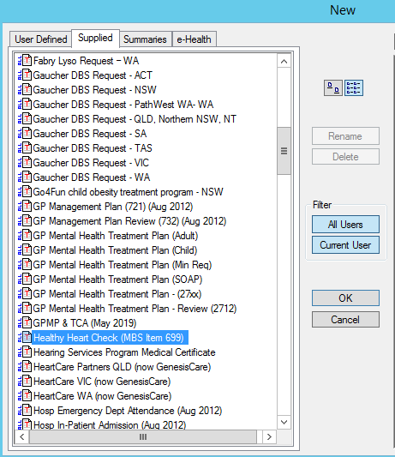
4. Complete the check by following the prompts on the screen

## Aboriginal and Torres Strait Islander Health Assessment (MBS item 715)

Indigenous health refers to the physical, cultural, social and emotional wellbeing of Aboriginal and/or Torres Strait Islander peoples (Indigenous Australians).

Many indigenous Australians experience poorer health than other Australians, often dying at much younger ages.

Indigenous Australians are more likely than non-Indigenous Australians to have respiratory diseases, mental health problems, cardiovascular disease, diabetes and chronic kidney disease.

### Who is eligible for an Aboriginal and Torres Strait Islander Health Assessment

The Aboriginal and Torres Strait Islander Peoples health assessment is available to:

* Children between ages of 0 and 14 years
* Adults between the ages of 15 and 54 years
* Older people over the age of 55 years.

See [MBS descriptor](http://www9.health.gov.au/mbs/search.cfm?q=715&Submit=&sopt=I)

### Aboriginal and Torres Strait Islander Assessment and Medicare

MBS item 715 must include the following elements:

* information collection, including taking a patient history and undertaking examinations and investigations as required;
* making an overall assessment of the patient
* recommending appropriate interventions
* providing advice and information to the patient
* keeping a record of the health assessment, and offering the patient, and/or patient's carer, a written report about the Health Assessment with recommendations about matters covered by the Health Assessment; and
* offering the patient's carer (if any, and if the general practitioner considers it appropriate and the patient agrees) a copy of the report or extracts of the report relevant to the carer.

### Completing Aboriginal and Torres Strait Islander Health Assessments on Medical Director

To complete the template in Medical Director:

1. Open the patient’s file
2. From the menu, select **Assessment** and **ATSI Health Assessment**

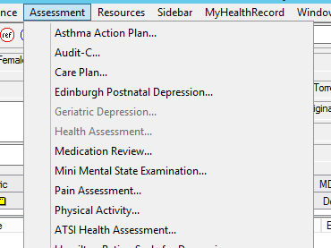

1. Complete the Health Assessment by following the prompts

### Completing Aboriginal and Torres Strait Islander Health Assessments on Best Practice

To complete the template in Best Practice:

1. Open the patient’s file
2. From the menu on the left-hand side, select the + next to Enhanced Primary Care
3. Click on Health **assessments**

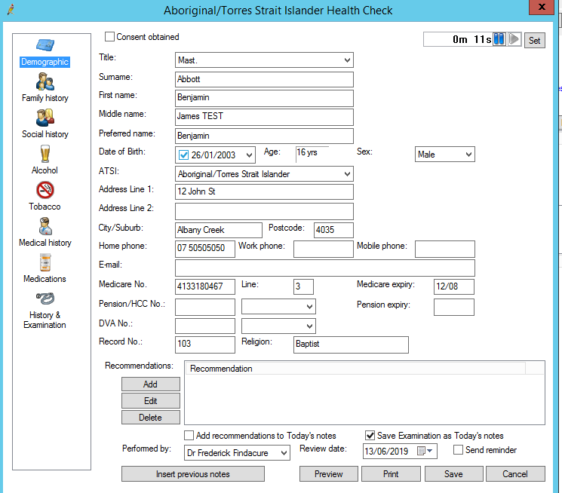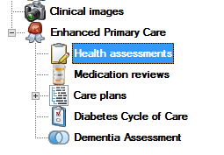

1. If you have the patient’s ethnicity status entered correctly, it will automatically open to the Health Assessment that the patient is eligible for.

## Activity 4.1 – Data collection from billing software package

Complete the below table by collecting data from your billing software package. Instructions are available for Pracsoft, Best Practice or [CAT4](https://help.pencs.com.au/display/CG/MBS+Items). Use the appropriate item numbers that are relevant for your practice from the list above.

*The aim of this activity is to collect data to determine the number of claims made for MBS items at your practice over the past 12 months.*

|  | Description | Total number of active patients as per RACGP criteria (3 x visits in 2 years) | Total number of active patients |
| --- | --- | --- | --- |
| 4.1a | Number of patients at high risk eligible for the *My health for life* program  *(from activity 1.1)* |  |  |
| 4.1b | Number of indigenous patients eligible for the *My health for life*program  *(from activity 1.1)* |  |  |
| 4.1c | Number of health assessment (MBS item 701, 703, 705 & 707) claimed in the past 12 months. |  |  |
| 4.1d | Number of health heart check (MBS item 699) claimed in the past 12 months |  |  |
| 4.1e | Number of Aboriginal and Torres Strait Islander (MBS item 715) claimed in the past 12 months |  |  |

*Please note: You may wish to change the dates of your searches to compare previous years and/or different time frames.*

Reflection comments as a result of completing Activity 4.1:

|  |
| --- |
|  |
|  |
|  |
|  |
| **Practice name: Date:** |
| **Team member:** |

### Instructions - Identifying the number of chronic disease item numbers claimed in Pracsoft.

To access the reports in Pracsoft,

1. From the main menu select **Reports** and **All reports**

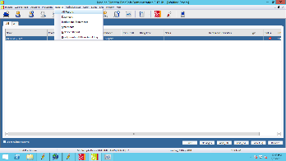

1. This will open up the **Report screen**:
2. Select **Fees, Report name: Practice fees** by item no, date range change to particular date range you are looking at (i.e.: July-June etc), page per practitioner select no and change the date selection to entry date.

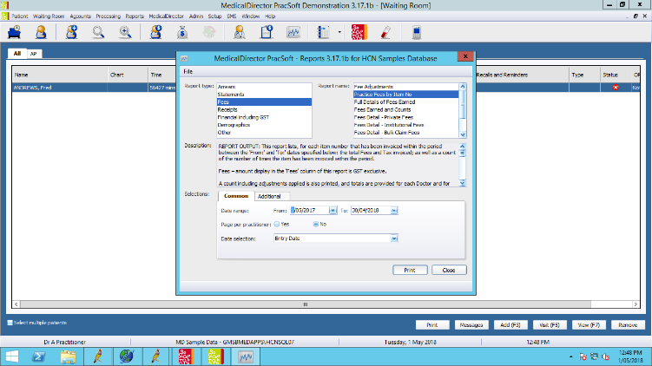

1. Then click on the **Additional**
2. In the Item box, list all the relevant item numbers with a comma separating each number
3. Select print and your report will appear on the screen. Write the total number completed on the data collection sheet at **Activity 4.1**. Please note: there are multiple numbers for each category. Add the number of items claimed per section together to get the total (for e.g. the number of 701, 703, 705, 707, 224, 225, 226, 227 completed all get added together to give you the total Health Assessments)

### Instructions - Identifying the number of chronic disease item numbers claimed in Best Practice

To access the reports in Best Practice:

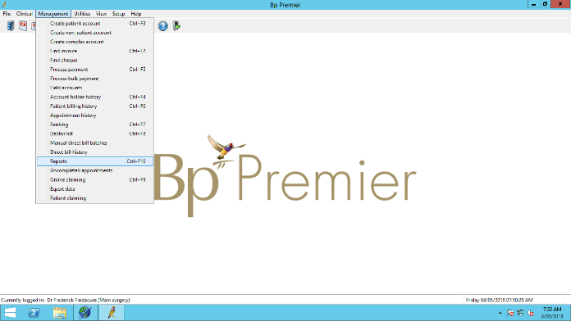

1. From the main screen, select **management and reports**

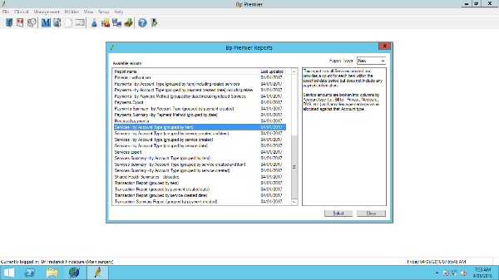

1. This will open up the report screen
2. Select **services** **– by account type** (group by item).
3. Select your date range to the particular timeframe you are looking at (i.e: July – June) under the **Date, Locations and Providers** tab

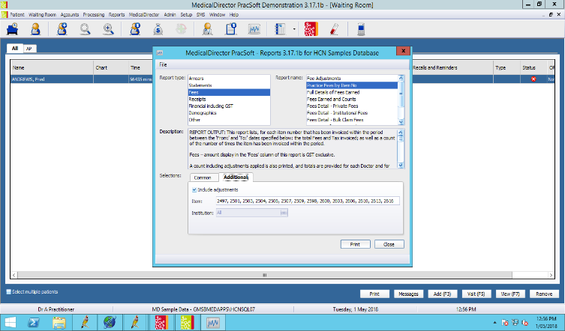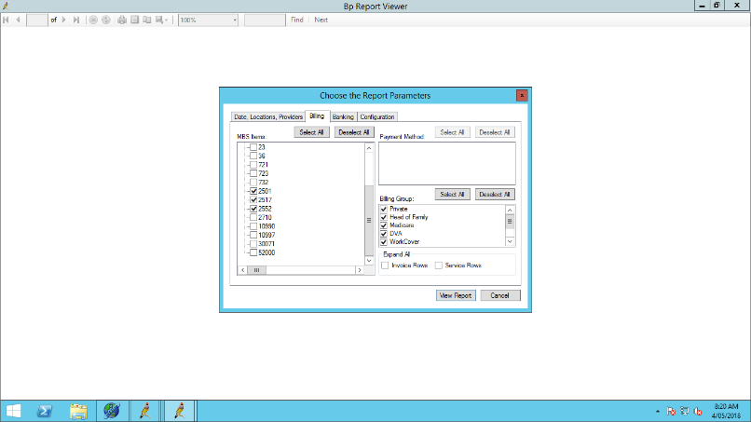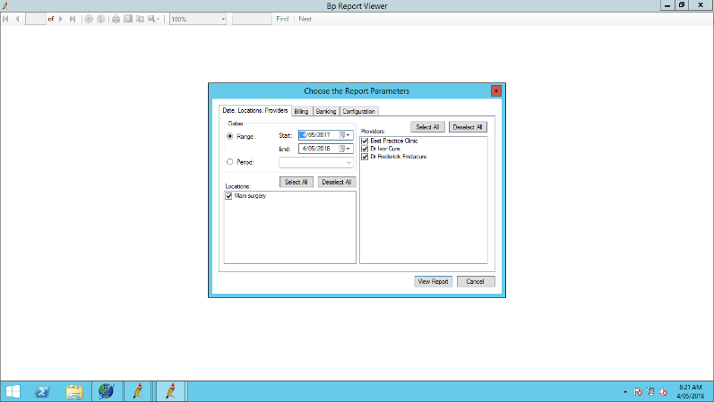

1. Click on the **Billing tab** and select the item numbers you would like to include in your report. Please note: the item numbers are only shown on this list, if there has been a claim for them at your practice
2. Click on the **View** report button
3. The report will then show the count per item number by provider
4. Write the total number completed on the data collection sheet at **Activity 4.1**

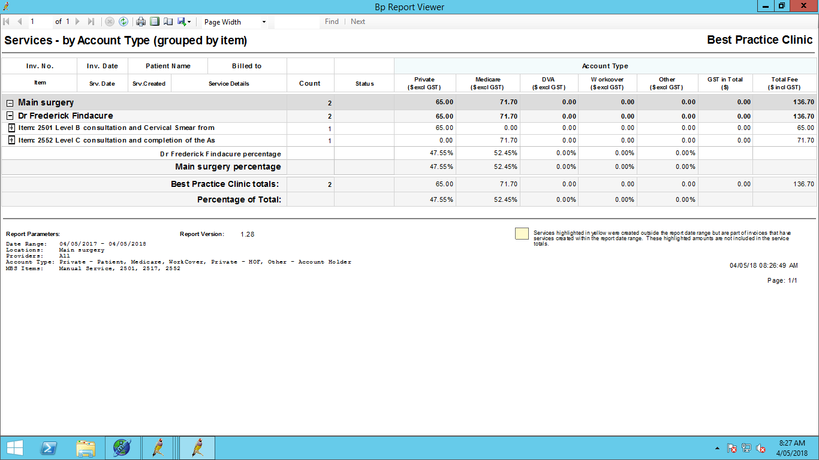

## Activity 4.2– Review MBS item number claiming at your practice

*The aim of this activity is to review your Medicare item number claiming for patients who may be eligible for the My health for life program*

| **Description** | **Status** | **Action to be taken** |
| --- | --- | --- |
| After completing activity 4.1 are there any unexpected results with your practice’s MBS claiming? |  Yes: **see actions to be taken**   No: continue with activity | Please explain: (*for e.g. low % of patients eligible for the My health for life program have a healthy heart check or high % of Aboriginal and Torres strait islander health assessments completed*)  How will this information be communicated to the practice team? |
| Do relevant team members know the criteria associated with claiming health assessments, healthy heart checks and Aboriginal and Torres Strait islander assessments? |  Yes: continue with activity   No: **see actions to be taken** | More information is available here:  [Health Assessments](#_Health_assessments_(MBS)  Healthy heart checks  Aboriginal health assessments |
| After reviewing your MBS claiming, are there any changes you would like to implement in the practice, to help manage patients, over the next 12 months? |  Yes: **see actions to be taken**   No: you have completed this activity | Refer to the Model for Improvement (MFI) and the Thinking part at the end of this document  Refer to the Doing part - PDSA of the Model for Improvement (MFI) to test and measure your ideas for success |

Reflection comments as a result of completing Activity 4.2:

|  |
| --- |
|  |
|  |
|  |
|  |
| **Practice name: Date:** |
| **Team member:** |

## Tools to help utilise MBS item numbers

### Medicare item numbers and Topbar

PenCS Pty Ltd (PENCS) have developed Topbar as an adjunct to the GP Clinical Desktop System to deliver useful tools and decision support information for the primary care sector at the point of care. Currently Topbar works with Best Practice, MD3 and the latest version of Zedmed.



The MBS app can assist in determining which MBS item is relevant for the patient currently open in the clinical system. Topbar looks at the billing history of the patient at the clinic only - Medicare currently does not allow third party access to information about billing elsewhere.

For more information about the MBS app

For each patient that is open on the clinical system, you will be able to view the list of Medicare item numbers that the patient is eligible for.

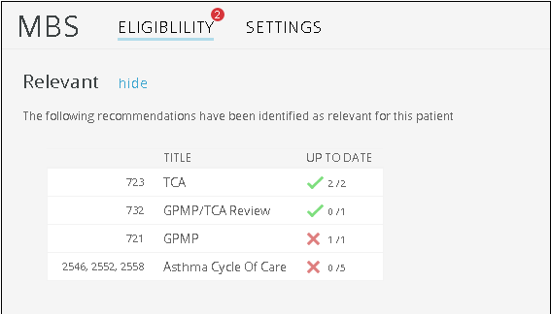

## Provider digital access (PRODA)

PRODA is an online authentication system used to securely access certain online services including HPOS. Designed as a two-step verification process, it requires a username, password and verification code to login. Practice staff can use PRODA to search for previous MBS item number billing and to check eligibility.

### For more information about Topbar or PRODA:

Brisbane North PHN have some instructions to assist with registration and using the portal.

* Topbar flip [guide](http://www.brisbanenorthphn.org.au/content/Document/Topbar-Brisbane-North-PHN-160711.pdf)
* PRODA [login](http://medicareaust.com/MISC/MISCP02/proda.html)
* HPOS education resources
* Health professionals [online learning modules](https://www.servicesaustralia.gov.au/organisations/health-professionals/subjects/education-services-health-professionals)

## Activity 5. *My health for life* referral process & patient journey

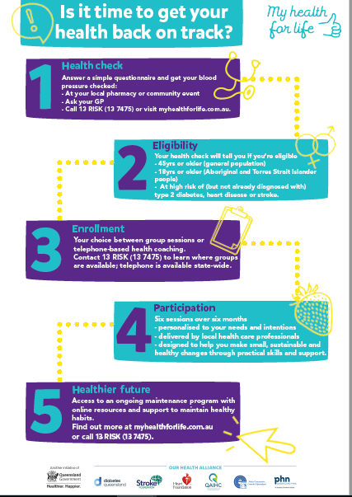

## *My health for life* referral form templates

GP referrals are sent to the *M*y health for life team at Diabetes Queensland via Medical Objects or fax 07 3506 0909.

Although GP referral is recommended, referrals can also be made by a practice nurse, allied health professional or the patient themselves by contacting 13 RISK (13 7475) or visiting the website to complete a health check.

Patients that self-refer into the program will require GP consent if they have any of the following:

* pregnant
* mental health issue
* current acute illness (i.e. cancer)
* surgery within the last 12 months
* high blood pressure either >160 systolic or >100 diastolic.

## Referral Templates

*My health for life* referral templates are available for the following software packages.

* [Best Practice Referral Template](https://bsphn.org.au/wp-content/uploads/2017/12/My-Health-For-Life-BP-V2.rtf)
* [Genie Referral Template](https://bsphn.org.au/wp-content/uploads/2018/01/My-Health-For-Life-Genie-V2.4w7)
* [GP Complete Referral Template](http://www.healthygc.com.au/GCPHN/media/Site-Pages-Content/Referral%20Templates/GP%20Complete/My-Health-For-Life-GPC-V1.rtf)
* [Medical Director Referral Template](https://bsphn.org.au/wp-content/uploads/2017/12/My-Health-For-Life-MD-V2.rtf)
* [Zedmed Referral Template](https://bsphn.org.au/wp-content/uploads/2017/12/My-Health-For-Life-ZM-V2.rtf)
* [Medical Practitioner Referral PDF](https://bsphn.org.au/wp-content/uploads/2017/10/GP-referral-form-template_19122017_fillable.pdf)

Instructions on how to import templates is available for [Best Practice](https://trainitmedical.com.au/wp-content/uploads/2012/07/BP-Summary-Sheet-Importing-Templates.pdf) & [Medical Director](https://trainitmedical.com.au/wp-content/uploads/2012/07/MD-Summary-Sheet-Importing-Templates.pdf).

## *My health for life* group facilitators

My health for life group facilitators and telephone health coaches come from a variety of healthcare backgrounds and include exercise physiologists, dietitians, nurses, psychologists, GPs and more. There is a network of over 120 experienced health practitioners across Queensland who have completed training to ensure they are equipped to guide and support participants through the program. More information about facilitators can be obtained by calling 13 7475 or from the [website](https://www.myhealthforlife.com.au/our-community/health-professionals).

## Activity 5.1– Review referral process for the *My health for life* program

*The aim of this activity is to review your referral process for the My health for life program*

| **Description** | **Status** | **Action to be taken** |
| --- | --- | --- |
| Do relevant team members know the eligibility criteria for the *My health for life* program? |  Yes: continue with activity   No: **see actions to be taken** | Refer to eligibility [criteria](https://bsphn.org.au/wp-content/uploads/2017/11/MH4L-eligibility-criteria-1.pdf) |
| Are electronic referral templates available on your clinical software package? |  Yes: continue with activity   No: **see actions to be taken** | Obtain appropriate referral templates [here](https://bsphn.org.au/primary-care-support/my-health-for-life/referral-form-templates/)  How will you let the team know that referral templates are now available? |
| Do relevant team members know who are the facilitators/groups in your area? |  Yes: continue with activity   No: **see actions to be taken** | Information from Brisbane North PHN’s [website](https://www.brisbanenorthphn.org.au/page/health-professionals/my-health-for-life/)  Or Phone MH4L on 13 7475  Or via the MH4L contact [form](https://www.myhealthforlife.com.au/contact) |
| After reviewing your *My health for life* referral process, are there any changes you would like to implement in the practice, to help manage patients, over the next 12 months? |  Yes: **see actions to be taken**   No: you have completed this activity | Refer to the Model for Improvement (MFI) and the Thinking part at the end of this document  Refer to the Doing part - PDSA of the Model for Improvement (MFI) to test and measure your ideas for success |

Reflection comments as a result of completing Activity 5.1:

|  |
| --- |
|  |
|  |
|  |
|  |
| **Practice name: Date:** |
| **Team member:** |

## Activity 6. Recall and reminders

As part of the RACGP accreditation standards, it is a requirement that practices provide health promotion, illness prevention, preventive care and a reminder system based on patient need and best available evidence.

### Reminders, recalls and prompts (flags)

Reminders are used to initiate prevention, before or during the patient visit. They can be either opportunistic or proactive. Recalls are a proactive follow up to a preventive or clinical activity. Prompts are usually computer generated, and designed to opportunistically draw attention during the consultation to a prevention or clinical activity needed by the patient. Using a recall system can seem complex, but there are three steps you can take:

* be clear about when and how you want to use these flags
* explore systems used by other practices, your PHN, and information technology specialists to ensure you get the correct system
* identify all the people who need to be recalled and place them in a practice register. This will help to ensure that the recall process is both systematic and complete.

### Train IT Medical – Recall and reminder resources for Medical Director

Train IT Medical have a number of resources available for practices to use to assist managing their recall and reminder systems. These include:

* [Sample Recall Management Protocol/Flowchart](https://trainitmedical.com.au/wp-content/uploads/2018/07/MD-Sample-Recall-Management-Protocol-No-actions.pdf)
* [Bulk Recall Cleanup](https://trainitmedical.com.au/wp-content/uploads/2018/07/Medical-Director-Summary-Sheet-Bulk-Recall-Cleanup-v2.pdf)
* [MedicalDirector learning resources](https://www.medicaldirector.com/help/#t=shared-content%2FStart_Clinical.htm)
* [Sample Quality Improvement Activity](https://trainitmedical.com.au/wp-content/uploads/2018/07/Setting-up-a-recall-and-reminder-systems-example-PDSA-Five-star-case-study-1.pdf)
* [Train IT Medical ‘Recalls, Reminders & Screening’ using MD Presentation](https://trainitmedical.com.au/presentations)
* [Read our MedicalDirector Clinical Top 5 ‘Recalls & Reminders’ Tips](https://trainitmedical.com.au/medicaldirector-clinical-top-5-recalls-reminders-tips)

### Train IT Medical – Recall and reminder resources for Best Practice

Train IT Medical have a number of resources available for practices to use to assist managing their recall and reminder systems. These include:

* [Reminders quick reference guide](https://trainitmedical.com.au/wp-content/uploads/2018/06/BpPremier_Indigo_QRG_Reminders.pdf)
* [Creating a reminder template](https://trainitmedical.com.au/wp-content/uploads/2012/07/BP_FAQ-BP-Creating-a-Reminder-Template.pdf)
* [Sending SMS reminders to patients](http://kb.bpsoftware.net/au/bppremier/lava/Content/Management/SMSReminders/UsingSMSReminders.htm?Highlight=sms)
* [Recall & reminders – why it’s so hard](https://trainitmedical.com.au/recalls-reminders-why-is-it-so-hard)

### Activity 6.1 – Reminder system

|  | **Status** | | **Action to be taken** |
| --- | --- | --- | --- |
| Is consent obtained from patients to be included in the practices reminder system? |  Yes, how is this done?   No, **see action to be taken** | | Include a section on New patient information sheet about consent to participate in reminder system  Clinicians ask patients prior to placing them on reminder system |
| How does the practice record if a patient **DOES NOT** wish to be contacted offering reminder appointments? |  | | |
| Do clinicians know how to initiate a patient reminder within clinical software? |  Yes, continue with activity   No, **see action to be taken** | | Clinician education on setting up patient reminders |
| How regularly are reminder lists generated for each doctor/nurse? | Doctor | Practice nurse | Create a practice policy for frequency of generating lists  Nominate a practice member to generate reminder lists |
|  |  |
| Is there a system for reviewing and actioning reminder lists? i.e.   * all posted * all telephoned * wait for patient to attend * GPs review lists and classifies reminders. |  Yes, continue with activity   No, **see action to be taken** | | Create policy for activating reminders due  Nominate a practice member to activate reminders due |
| Is there a system to identify in the appointment book when a patient is coming in for a reminder appointment |  Yes, continue with activity   No, **see action to be taken** | | Use of a symbol in the appointment book to identify type of appointment |
| Is there a process for acting on or removing outstanding reminders? E.g. patients fail to attend, reminder no longer needed |  Yes, continue with activity   No, **see action to be taken** | | GP education on removing reminders  Document practice process on removing reminders |
| Is there a practice policy on how reminders are to be implemented? E.g. *entering all reminders for the upcoming 12 months to ensure all tests are performed*? |  Yes, policy is working   Yes, policy is not working, see action to be taken   No policy, **see action to be taken** | | Revise policy  Practice policy on reminders to be implemented |
| Is there a system for ensuring patients recently diagnosed with diabetes are incorporated into the reminder system |  Yes, policy is working   Yes, policy is not working, see action to be taken   No policy, **see action to be taken** | | Revise policy  Practice policy on reminders to be implemented |
| After reviewing your practice recall and reminder system, are there any changes you would like to implement in the practice, to help manage patients, over the next 12 months? |  Yes, **see actions to be taken**   No, you have completed this activity | | Refer to the Model for Improvement (MFI) and the Thinking part at the end of this document.  Refer to the Doing part - PDSA of the Model for Improvement (MFI) to test and measure your ideas for success |

## Recommendation – other methods for engaging patients

* Decide on targeted promotional material (posters/flyers) for your practice waiting room
* Include promotional material on your website
* Develop an invitation letter for patients

Reflection comments as a result of completing Activity 6.1:

|  |
| --- |
|  |
|  |
|  |
|  |
| **Practice name: Date:** |
| **Team member:** |

## Activity 7. *My health for life* resources and training

## Guidelines

* RACGP [Guide for prevention in General Practice (Red Book)](https://www.racgp.org.au/download/Documents/Guidelines/Redbook9/17048-Red-Book-9th-Edition.pdf)
* [Guidelines for secondary prevention of coronary heart disease](https://www.heartfoundation.org.au/images/uploads/publications/Reducing-risk-in-heart-disease.pdf)
* [Quick reference guide for health professionals - Absolute cardiovascular disease risk management](https://www.heartfoundation.org.au/images/uploads/publications/Absolute-CVD-Risk-Quick-Reference-Guide.pdf)
* RACGP [National guide to a preventive health assessment for Aboriginal and Torres Strait Islander people](https://www.racgp.org.au/clinical-resources/clinical-guidelines/key-racgp-guidelines/view-all-racgp-guidelines/national-guide)

## Tools

* *My health for life* [risk assessment](https://www.myhealthforlife.com.au/risk-assessment)
* [Australian absolute cardiovascular disease risk calculator](https://www.cvdcheck.org.au/)
* [Australian Type 2 diabetes risk assessment calculator](https://www1.health.gov.au/internet/main/publishing.nsf/Content/chronic-diab-prev-aus)
* [Heart Online: Heart Education Assessment Rehabilitation Toolkit](http://www.heartonline.org.au/)
* [The change program - GP Weight Management toolkit](http://www.changeprogram.com.au/)

## Resources

* *My health for life* [program outline](https://bsphn.org.au/wp-content/uploads/2019/01/My-health-for-life-program-outline.pdf)
* *My health for life* [eligibility flow chart](https://www.ourphn.org.au/wp-content/uploads/20190115-Eligibility-criteria_My-health-for-life.pdf)
* *My health for life* [FAQs](https://bsphn.org.au/wp-content/uploads/2017/11/MH4L-FAQs.pdf)
* ECCQ *My health for life* [information sheet](https://bsphn.org.au/wp-content/uploads/2018/03/MH4L_info-sheet-for-GPs-servicing-CALD-communities.pdf)
* [*My Health for Life* Facebook page](https://www.facebook.com/MyhealthforlifeQLD/)
* Heart Foundation [Preventing chronic disease through physical activity](https://www.heartfoundation.org.au/news/preventing-chronic-diseases-through-physical-activity) –
* The Department of Health – Medicare Health Assessment Resource Kit
* RACGP [Conducting quality health assessments in General Practice](https://www.aci.health.nsw.gov.au/__data/assets/pdf_file/0005/257468/APNA_RACGP_quality_health_assessment_info_sheet.pdf)
* Heart foundation [for health professionals](https://www.heartfoundation.org.au/for-professionals)

## Training and information

* [APNA cardiovascular disease risk assessment modules](https://apna.kineoportal.com.au/content/store/productinfo.jsp?category=Chronic%20Conditions&productid=628)
* [Motivational Interviewing techniques for health professionals to support health behaviour change](http://www.heartonline.org.au/articles/behaviour-change/supporting-behaviour-change)
* [Aboriginal Health - information and resources for health professionals](https://www.heartfoundation.org.au/for-professionals/aboriginal-health-resources)
* [Heart Online Supporting behaviour change](https://www.heartonline.org.au/articles/behaviour-change/supporting-behaviour-change)
* [APNA Cardiovascular disease risk assessment and management - Free 2 hour course for nurses](https://apna.kineoportal.com.au/content/store/productinfo.jsp?category=Chronic%20Conditions&productid=628)
* [HotDoc Webinar Calculating Absolute Cardiovascular Risk & Relevant Health Assessments in General Practice](https://www.hotdoc.com.au/practices/blog/cardiovascular-risk/?utm_campaign=Webinars&utm_medium=email&_hsenc=p2ANqtz-_SnaMmeRozJraHdrre3nHElrWMrJre9SYn4Lq6sGn4bVQXJ2IbpaTAzqUnBYcgpCOrLhFqszKoYGfd5axXFfb4pqEvfQ&_hsmi=72916847&utm_content=72916847&utm_source=hs_email&hsCtaTracking=84f89f55-dca9-442a-828a-18f5a1a555ac%7C70a4dae7-90da-43e2-b4b4-25cadb2c6729)
* Brisbane North PHN [Medical Assisting](https://www.brisbanenorthphn.org.au/page/health-professionals/Medical+Assisting/)
* UNEP [Cert IV in Medical Practice Assisting](https://www.unep.edu.au/course/certificate-iv-in-medical-practice-assisting/)

## How to adopt an absolute risk approach in your practice (5 short interviews with leading experts)

* [Absolute risk and what it means in practice](https://vimeo.com/16198026) (05:24)
* [Reducing barriers to using an absolute risk approach](https://vimeo.com/16198100) (04:17)
* [Engaging patients to think about absolute risk](https://vimeo.com/16198152) (04:58)
* [Absolute risk assessment in Aboriginal and Torres Strait Islander populations](https://vimeo.com/16198258) (02:13)
* [Other issues in absolute risk assessment](https://vimeo.com/16198298) (03:53)

## Information for patients:

* [*My health for life* patient information flyer](https://bsphn.org.au/wp-content/uploads/2018/12/My-health-for-life-flyer.pdf)
* *My health for life* [program information booklet](https://www.ourphn.org.au/wp-content/uploads/20190115-BDIQ0012-A5-Introduction-Brochure.pdf)
* [Healthier Happier](http://www.healthier.qld.gov.au)
* [Know your risks](https://www.heartfoundation.org.au/your-heart/know-your-risks)
* [Heart health check poster (PDF)](https://www.heartfoundation.org.au/images/uploads/main/For_professionals/HHC_poster_2018.pdf)
* [Heart health check brochure (PDF)](https://www.heartfoundation.org.au/images/uploads/main/For_professionals/Heart_health_check_brochure_2018.pdf)
* [Patient resource - Manage your stroke and heart risk (PDF)](https://www.heartfoundation.org.au/images/uploads/publications/HF-consumer-Manage-your-heart-stroke-risk.pdf)
* [Guide to healthy eating for adult brochure](https://www.eatforhealth.gov.au/guidelines)
* [Quitline - for smoking cessation tools, information and resources](http://www.quitnow.gov.au/)
* [Family history screening questionnaire](https://www.racgp.org.au/download/Documents/Guidelines/Redbook9/Appendix-2A-Family-history-screening-questionnaire.pdf)

## How your general practice can get involved

* 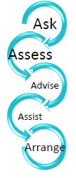Use waiting room promotion
* Use [MH4L CAT4 recipes](https://help.pencs.com.au/display/CR/My+Health+For+Life+Recipes) and/or review existing CAT4 CV event risk to help identify and recall at risk patients
* Encourage patients to complete the online [MH4L risk assessment](https://www.myhealthforlife.com.au/risk-assessment)
* Ask nursing staff to complete initial [risk assessment](https://www.myhealthforlife.com.au/risk-assessment) with patients
* Encourage patients to complete the [AUSDRISK Calculator](https://www1.health.gov.au/internet/main/publishing.nsf/Content/chronic-diab-prev-aus)
* Talk with the identified high-risk patients about the program, assess readiness for change and [refer](https://www.myhealthforlife.com.au/our-community/health-professionals) to the program.

## Quality Improvement Activities using The Model for Improvement and PDSA

After completing any of the workbook activities above you may identify areas for improvement in the management of patients eligible for the *My health for life* program. Follow these steps to conduct a Quality Improvement Activity using The Model for Improvement and PDSA. The model consists of two parts that are of equal importance.

Step 1: The **‘thinking’** part consists of three fundamental questions that are essential for guiding improvement work:

* What are we trying to accomplish?
* How will we know that the proposed change will be an improvement?
* What changes can we make that will lead to an improvement?

Step 2: The **‘doing’** part is made up of Plan, Do, Study, Act (PDSA) cycles that will help to bring about rapid change. This includes:

* Helping you test the ideas
* Helping you assess whether you are achieving your desired objectives
* Enabling you to confirm which changes you want to adopt permanently.

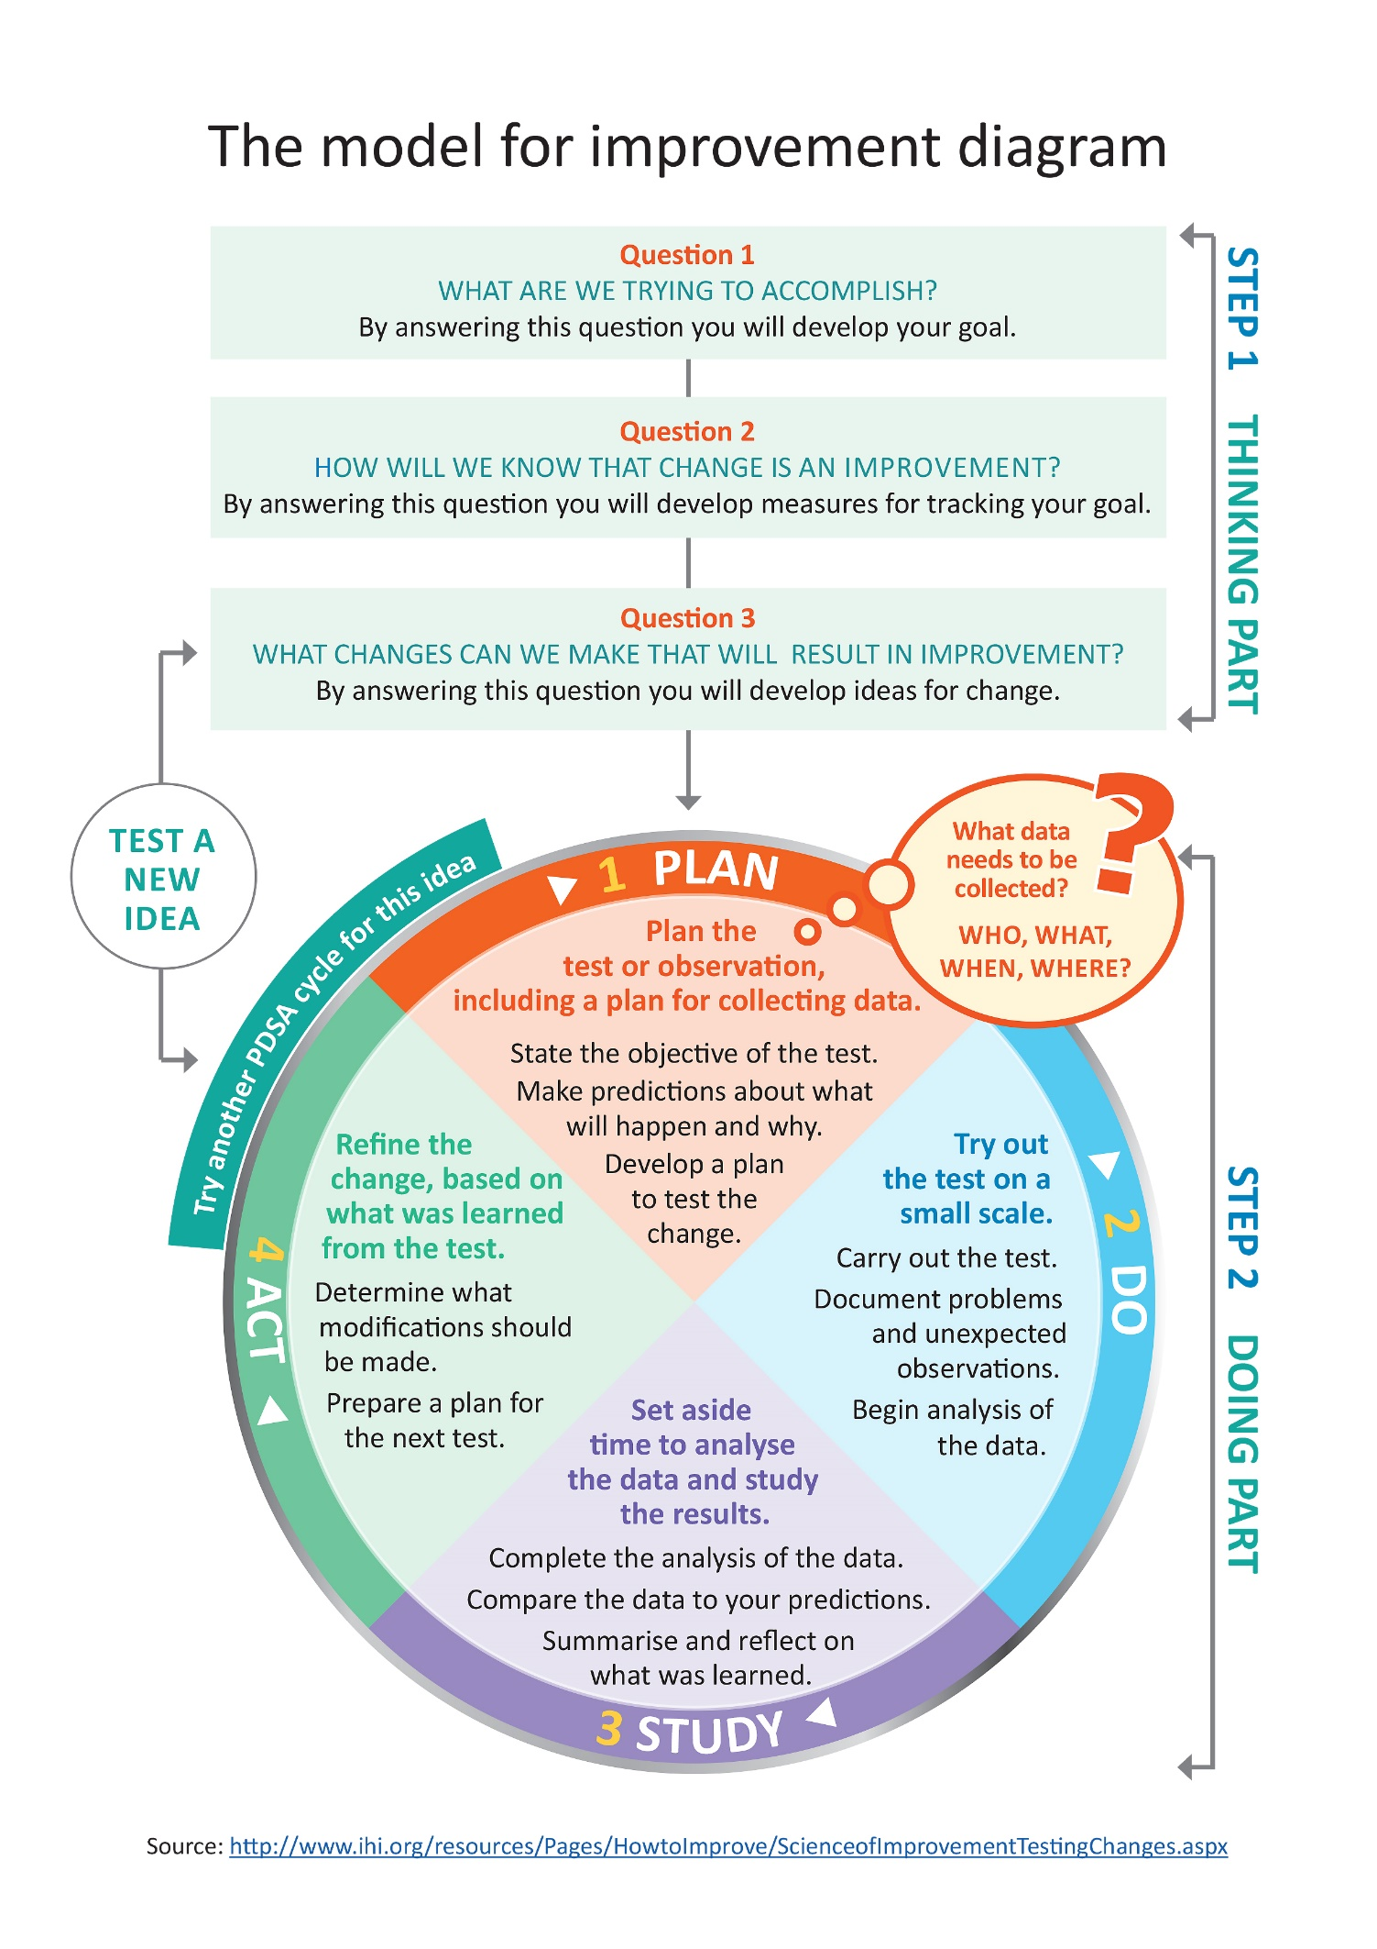

## Model for Improvement and PDSA worksheet EXAMPLE

**Step 1: The Thinking Part** - The 3 Fundamental Questions

|  |  |
| --- | --- |
| Practice name: | Date: |
| Team member: | |
| Q1. What are we trying to accomplish? (Goal) | |
| *By answering this question, you will develop your goal for improvement* | |
| Our goal is to:   * Increase the number of *My health for life* referrals for eligible patients   *This is a good start, but how will you measure whether you have achieved this goal? The team will be more likely to embrace change if the goal is more specific and has a time limit.*  *So, for this example, a better goal statement would be:*  Our S.M.A.R.T. goal is to:   * Increase the number of *My health for life* referrals for patients with high cholesterol eligible for the program by 10% by 30th April. | |
| Q2. How will you know that a change is an improvement? (Measure) | | |
| *By answering this question, you will develop MEASURES to track the achievement of your goal.*  *E.g. Track baseline measurement and compare results at the end of the improvement.* | | |
| We will measure the number of MH4L referrals for patients with high cholesterol eligible for the program. To do this we will:  A) Identify the number of active patients with high cholesterol eligible for the MH4L program  B) Identify the number of active patients with high cholesterol referred to the MH4L program  B divided by A x 100 produces the percentage of patients with high cholesterol who have been referred to MH4L program | | |
| Q3. What changes could we make that will lead to an improvement? (List your IDEAS) | |
| *By answering this question, you will develop the IDEAS that you can test to achieve your CHANGE goal.*  *You may wish to BRAINSTORM ideas with members of our Practice Team.* | |
| Our ideas for change:   1. Identify patients with high cholesterol who are eligible for the MH4L program by completing a search on CAT4. 2. All patients aged between 40 & 50 years are offered to complete an AusDRISK questionnaire in the waiting room. This option would capture any under-screened patients. 3. Create a prompt on TopBar to ensure all patients with high cholesterol who are eligible for the MH4L program are offered a referral. 4. Clinical team discuss how they can ensure cholesterol results are recorded on targeted population. 5. Source and provide endorsed patient education resources (in waiting rooms, toilets etc)   The team selects one idea to begin testing with a PDSA cycle | |

**Note: Each new GOAL (1st Fundamental Question) will require a new Model for Improvement Guide**

Source: Langley, G., Nolan, K., Nolan, T., Norman, C. & Provost, L. 1996, The Improvement Guide, Jossey-Bass, San Francisco, USA.

**Model for Improvement and PDSA worksheet EXAMPLE**

**Step 2: The Doing Part** - Plan, Do, Study, Act

*You will have noted your IDEAS for testing when you answered the third Fundamental Question in Step 1*

*You will use this sheet to test an idea.*

|  |  |  |  |  |
| --- | --- | --- | --- | --- |
| PLAN | | | Describe the brainstorm idea you are planning to work on. (Idea) | |
| *Plan the test, including a plan for collecting data* | | | *What exactly will you do? include what, who, when, where, predictions and data to be collected* | |
| Idea:Identify patients with high cholesterol with no referral to the *My health for life program.*  What: Tom will set aside an hour on a Thursday afternoon to conduct a search on CAT4 of all patients with high cholesterol eligible for the *My health for life* program. A top bar prompt will then be created to ensure these patients have an AusDRISK assessment done at their next appointment.  Who: Practice manager  When: Begin 10th January  Where: in the Practice manager office  Prediction: 15% of the active patient with high cholesterol eligible for the MH4L program will have been referred to the program.  Data to be collected: Number of active patients with high cholesterol eligible for the MH4L program. | | | | |
| DO | **Who is going to do what? (Action)** | | | |
| *Run the test on a small scale* | How will you measure the outcome of your change? | | | |
| Completed by 10th April – individual GP reports were generated from CAT4 outlining patients with high cholesterol eligible for the MH4L program. It was identified 3 of the GPs in the practice were unaware of the *My health for life program.* Education and training was provided to the practice team in relation to the program criteria. | | | | |
| STUDY | | **Does the data show a change? (Reflection)** | | |
| *Analyse the results and compare them to your predictions* | | *Was the plan executed successfully?*  *Did you encounter any problems or difficulty?* | | |
| A total of 27 active patients (9%) with high cholesterol have been referred to the *My health for life* program. = 6% lower than predicted | | | | |
| ACT | | | | **Do you need to make changes to your original plan? (What next)**  **OR Did everything go well?** |
| *Based on what you learned from the test, plan for your next step* | | | | *If this idea was successful you may like to implement this change on a larger scale or try something new*  *If the idea did not meet its overall goal, consider why not and identify what can be done to improve performance* |
| 1. Create a PenCS Topbar prompt to ensure all patients with high cholesterol are prompted to receive a referral to the MH4L program. 2. Ask the medical receptionist to offer an AusDRISK questionnaire to patients aged between 40 & 50 years whilst waiting to see their GP 3. Encourage the practice nurse to complete the referrals to the MH4L program if patient is identified at medium or high risk 4. Remind the whole team that this is an area of focus for the practice. | | | | |

**Repeat Step 2 for other ideas – What idea will you test next?**

## Model for Improvement and PDSA worksheet template

**Step 1: The Thinking Part** - The 3 Fundamental Questions

|  |  |
| --- | --- |
| Practice name: | Date: |
| Team member: | |
| Q1. What are we trying to accomplish? (Goal) | |
| *By answering this question, you will develop your GOAL for improvement* | |
|  | |
| Q2. How will you know that a change is an improvement? (Measure) | |
| *By answering this question, you will develop MEASURES to track the achievement of your goal.*  *E.g. Track baseline measurement and compare results at the end of the improvement.* | |
|  | |
| Q3. What changes could we make that will lead to an improvement? (List your IDEAS) | |
| *By answering this question, you will develop the IDEAS that you can test to achieve your CHANGE goal.*  *You may wish to BRAINSTORM ideas with members of our Practice Team.* | |
| Idea:  Idea:  Idea:  Idea: | |

**Note: Each new GOAL (1st Fundamental Question) will require a new Model for Improvement plan.**

Source: Langley, G., Nolan, K., Nolan, T., Norman, C. & Provost, L. 1996, The Improvement Guide, Jossey-Bass, San Francisco, USA.

**Model for Improvement and PDSA worksheet template**

**Step 2: The Doing Part** - Plan, Do, Study, Act cycle

*You will have noted your IDEAS for testing when you answered the third Fundamental Question in Step 1*

*You will use this sheet to test an idea.*

|  |  |
| --- | --- |
| PLAN | Describe the brainstorm idea you are planning to work on. (Idea) |
| *Plan the test, including a plan for collecting data* | *What exactly will you do? Include what, who, when, where, predictions and data to be collected* |
|  | |
| DO | **Who is going to do what? (Action)** |
| *Run the test on a small scale* | *How will you measure the outcome of your change?* |
|  | |
| STUDY | **Does the data show a change? (Reflection)** |
| *Analyse the results and compare them to your predictions* | *Was the plan executed successfully?*  *Did you encounter any problems or difficulty?* |
|  | |
| ACT | **Do you need to make changes to your original plan? (What next)**  **OR Did everything go well?** |
| *Based on what you learned from the test, plan for your next step* | *If this idea was successful you may like to implement this change on a larger scale or try something new.*  *If the idea did not meet its overall goal, consider why not and identify what can be done to improve performance.* |
|  | |

**Repeat Step 2 for other ideas - What idea will you test next?**

1. *Statistics provided by the My health for life program. Current October 2019*
2. <https://www.racgp.org.au/clinical-resources/clinical-guidelines/key-racgp-guidelines/view-all-racgp-guidelines/red-book/preamble/i-introduction#ref-num-1>
3. <http://static.diabetesaustralia.com.au/s/fileassets/diabetes-australia/b1126d58-2763-403a-bd2d-44a241bb9189.pdf>
4. *Heart Foundation Australia*